МИНИСТЕРСТВО ОБРАЗОВАНИЯ И НАУКИ

РОССИЙСКОЙ ФЕДЕРАЦИИ

МИРЭА – РОССИЙСКИЙ ТЕХНОЛОГИЧЕСКИЙ УНИВЕРСИТЕТ

**АНГЛИЙСКИЙ ЯЗЫК**

**ДЛЯ ИНЖЕНЕРОВ (А2-В2)**

УЧЕБНО-МЕТОДИЧЕСКОЕ ПОСОБИЕ

ЧАСТЬ 1

Москва – 2023

УДК 811.111(075.8)

ББК 81.432.1я73

[Электронный ресурс]: Учебно-методическое пособие / Н.В. Ялаева, Н.А.Быстров, Т.В.Кудинова, Н.И. Чернова, Н.В. Катахова. – М.: МИРЭА – Российский технологический университет, 2023. – 1 электрон. опт. диск (CD-ROM).

Учебно-методическое пособие содержит текстовой материал и лексико-грамматические упражнения, направленные на формирование и развитие коммуникативных навыков в на английском языке.

Пособие предназначено для организации аудиторной, внеаудиторной и самостоятельной работы студентов 1 курса, обучающихся по направлениям

Учебно-методическое пособие издается в авторской редакции.

Рекомендовано к изданию на заседании кафедры иностранных языков, протокол № от 2023 г.

Авторский коллектив:

Ялаева Наталья Вячеславовна, доцент каф. иностранных языков РТУ МИРЭА

Быстров Никита Александрович, ассистент каф. иностранных языков РТУ МИРЭА

Кудинова Татьяна Викторовна, старший преподавтель каф. иностранных языков РТУ МИРЭА

Чернова Надежда Ивановна, профессор каф. иностранных языков РТУ МИРЭА

Катахова Наталия Владимировна, доцент каф. иностранных языков РТУ МИРЭА

Рецензенты:

Васильев Андрей Георгиевич, д.ф-м.н., профессор, директор Института радиоэлектроники и информатики, «МИРЭА – Российский технологический университет» РТУ МИРЭА

Боровкова Марина Владимировна, к.ф.н., доцент кафедры русского, иностранных языков и культуры речи, Уральский государственный юридический университет им. В.Ф. Яковлева (Екатеринбург, Россия)

Системные требования:

Наличие операционной системы Windows, поддерживаемой производителем.

Наличие свободного места в оперативной памяти не менее 128 Мб.

Наличие свободного места в памяти постоянного хранения (на жестком диске) не менее 30 Мб.

Наличие интерфейса ввода информации.

Дополнительные программные средства: программа для чтения pdf-файлов (Adobe Reader).

Подписано к использованию по решению Редакционно-издательского совета

МИРЭА – Российского технологического университета от __ __________ 2023 г.

Объём: ___ Мб

Тираж 10

© МИРЭА – Российский технологический университет, 2023

Contents

PART I. I AM AN ENGINEERING STUDENT 6

Unit 1. About myself and my family 6

LEAD IN 6

Theme 1.1. Family and Friends 6

KEY WORDS AND WORD COMBINATIONS 6

PRONUNCIATION PRACTICE 7

VOCABULARY 8

GRAMMAR I 9

GRAMMAR II 11

READING 13

LISTENING 15

SPEAKING 16

WRITING 18

Theme 1.2. Hobbies and Interests 20

LEAD IN 20

KEY WORDS AND WORD COMBINATIONS 20

PRONUNCIATION PRACTICE 21

VOCABULARY 21

GRAMMAR I 24

READING 24

GRAMMAR II 26

LISTENING 27

GRAMMAR III 28

SPEAKING 31

WRITING 31

Theme 1.3. Life Stories 34

LEAD-IN 34

KEY WORDS AND WORD COMBINATIONS 34

PRONUNCIATION PRACTICE 35

VOCABULARY I 36

GRAMMAR REVISION. SIMPLE AND PROGRESSIVE TENSES 39

LISTENING 40

VOCABULARY II 42

READING 44

SPEAKING 47

WRITING 48

UNIT 2. Higher Education in Russia and Abroad 49

LEAD IN 49

Theme 2.1. Higher Education in Great Britain 49

KEY WORDS AND WORD COMBINATIONS 49

PRONUNCIATION PRACTICE 50

VOCABULARY I 53

GRAMMAR I 55

READING I 57

LISTENING I 60

VOCABULARY II 61

READING II 63

LISTENING II 65

SPEAKING 67

WRITING 67

Theme 2.2. Higher Education in the USA 70

LEAD IN 70

PRONUNCIATION PRACTICE 71

VOCABULARY I 72

GRAMMAR 73

READING I 75

GRAMMAR REVISION 81

VOCABULARY II 82

READING II 82

LISTENING II 84

SPEAKING 85

WRITING 86

SUPPLEMENTARY EXERCISES 90

GRAMMAR REFERENCE 93

THE VERB “TO BE” 93

VERB TENSES – ACTIVE VOICE 93

THE VERB “TO HAVE” 94

THE VERB + -ING FORM 95

PROGRESSIVE ACTIVE 95

PASSIVE. SIMPLE AND CONTINUOUS 97

THE PERFECT TENSES 99

ВВЕДЕНИЕ

# PART I. I AM AN ENGINEERING STUDENT

# Unit 1. About myself and my family

## LEAD IN



**Work in pairs and explain how you understand this quotation:**

*Family is not an important thing. It's everything.*

*- Michael J. Fox*

## Theme 1.1. Family and Friends

### KEY WORDS AND WORD COMBINATIONS

|  |  |  |
| --- | --- | --- |
| to introduce (v) | [ˌɪntrəˈdju:s] | знакомить, представлять |
| system analyst (n+n) | ['sɪstɪm'ænəlɪst] | системный аналитик |
| to work for a company (v+prep.+n) | [wɜ:k fɔ: ə 'kʌmpənɪ] | работать в компании |
| first-year student (n) | [fɜ:st ˈjɪə ˈstju:dənt] | студент-первокурсник |
| programmer (n) | ['prəugræmə] | программист |
| precious (adj) | [‘preʃəs] | драгоценный, любимый |
| understanding (n) | [ˌʌndəˈstændɪŋ] | понимание |
| support (n) | [sə'pɔ:t] | поддержка, помощь, опора |
| robotics engineer (n+n) | [rə(u)'bɔtɪks 'enʤɪ'nɪə] | инженер-робототехник |
| enterprise (n) | ['entəpraɪz] | предприятие |
| to follow the tradition (v+n) | ['fɔləu trə'dɪʃ(ə)n] | следовать традициям |
| Institute of Artificial Intelligence (n+adj.+n) | ['ɪnstɪtju:t ɔv ['ɑ:tɪ'fɪʃ(ə)lɪn'telɪʤ(ə)ns] | Институт Искусственного Интеллекта |
| to share smth with smb (v+prep.+n) | [ʃeə sʌmθɪŋ wɪð 'sʌmbədɪ] | делиться чем-то с кем-то |
| to solve problems (v+n) | [sɔlv 'prɔbləms] | разрешать проблемы |
| to go hiking (v+n) | [gəu 'haɪkɪŋ] | ходить в походы |
| jogging (n) | ['ʤɔgɪŋ] | бег трусцой |
| to take pictures (v+n) | [teɪk pɪkʧəz] | фотографировать |

### PRONUNCIATION PRACTICE

**Exercise 1**

**Practice saying the key words and word combinations.**

**Exercise 2**

**Reading rules. Read the words paying attention to the reading rules.**

**Letter “A”**

|  |  |  |  |
| --- | --- | --- | --- |
| [eɪ] | [æ] | [ɑ:] | [eə] |
| name | man | large | hair |
| make | family | task | fair |
| nature | travel | park | parents |

**Letter “E”**

|  |  |  |  |
| --- | --- | --- | --- |
| [i:] | [e] | [ɜ:] | [ɪə] |
| me | let | her | here |
| week | rest | term | dear |
| see | tennis | nerve | year |

**Letter “I”**

|  |  |  |  |
| --- | --- | --- | --- |
| [aɪ] | [ɪ] | [ɜ:] | [aɪə] |
| hiking | sister | girl | tire |
| enterprise | thing | first | fire |
| diving | consist | bird | liar |

**Letter “O”**

|  |  |  |  |  |
| --- | --- | --- | --- | --- |
| [əʋ] | [ɒ] | [ɔ:] | | [ʌ] |
| no | not | born | sports | love |
| hope | stop | port | more | company |
| most | jogging | for | before | become |

**Letter “U”**

|  |  |  |  |
| --- | --- | --- | --- |
| [ju:] | [ʌ] | [ɜ:] | [jʋə] |
| introduce | but | turn | pure |
| pupil | study | burn | cure |
| university | summer | hurt |  |

**Exercise 3**

**Read international words and translate them:**

school, tradition, student, university, lecture, seminar, problems, speciality, park, sport, football, basketball, character, organized, disciplined.

### VOCABULARY

**Exercise 4**

**Continue the list of words and give a general term to each group.**

Mother, father, sister, brother – family;

robotics engineer, computer programmer… - .

hiking, jogging,…. - .

**Exercise 5**

**Make all possible word combinations and translate them into Russian.**

|  |  |
| --- | --- |
| 1. to be | 1. busy |
| 1. to work at | 1. four people |
| 1. to study at | 1. born |
| 1. to consist of | 1. a good time |
| 1. to have | 1. university |
|  | 1. enterprise |

### GRAMMAR I

**Study grammar rules on the use of the verb TO BE (see GRAMMAR REFERENCE p.91)**

**Exercise 6**

**Write the correct form of the verb ‘to be’.**

1. My name ___ Tom and I ___ born in London.
2. Our family ___ not large.
3. His mother __ a writer.
4. We___ first year students of the Russian Technological University.
5. We ___busy yesterday.
6. Mikhail Kalashnikov___ a Soviet and Russian inventor and military engineer.
7. He____a computer programmer in 5 years.

**Exercise 7**

1. **Complete the dialogue with the correct forms of the verb ‘to be’.**

A: Hello. What is your name?

B: Hello. My name _____Ivan.

A: And my name _____ Alina. ____ you a student of the Russian Technological University MIREA?

B: Yes, I _____ a first-year student. And you?

A: I ____ a second-year student of the Institute of Artificial Intelligence. Where ____you from?

B: I ____ from Moscow, but I ____ born in Perm.

A: ____ your parents engineers?

B: Yes, they ____. My mother ___ a systems analyst and my father __ a robotics engineer.

1. **Practice the dialogue with the partner.**

**Exercise 8**

**Rewrite the sentences below as questions.**

|  |  |  |
| --- | --- | --- |
| **Sentence** | **Yes/No-Question** | **Wh-Question**  **(What? When? Who? Why? Where?)** |
| 1. His name is Alex. | Is his name Alex? | What is his name? |
| 2. We are first year students. |  |  |
| 3. Olga is a second-year student. |  |  |
| 4. My father is a systems analyst. |  |  |
| 5. Her mother was born in Yekaterinburg. |  |  |
| 6. We will be computer programmers. |  |  |
| 7. My grandparents were engineers. |  |  |

**Exercise 9**

**Translate the following sentences.**

1. Our family is quite large by modern standards.
2. My mother is a systems analyst.
3. My family is the most precious thing for me, because this is where I find love, understanding and support.
4. My sister Ann is five years younger than me.
5. My dream is to become a computer programmer.
6. My grandparents were engineers.
7. He will be a robotics engineer.

### GRAMMAR II

**Study grammar rules on the use of VERB TENSES – ACTIVE VOICE (see GRAMMAR REFERENCE p.91)**

**Exercise 10**

**Give the infinitive form of the verb:**

studied, gave, did, went, found, chose, consisted, worked, decided, helped, took, read

**Exercise 11**

**Say that you did it before. Use the following word combinations:**

|  |
| --- |
| *yesterday morning (evening, afternoon); when I was…..; …days (years) ago; last night (week, year, month, Sunday)* |

1. I watch movies.
2. I study English at school.
3. I do my homework.
4. I go to the swimming pool.
5. I play football.
6. I have a lot of free time.
7. I take guitar lessons.
8. I give much time to exams preparation.

**Exercise 12**

**Read pairs of sentences. Choose the correct one.**

1. a. Where do you study?

b. Where you study?

2. a. She work at a big enterprise.

b. She works at a big enterprise.

3. a. Peter and Jane go hiking in summer.

b. Peter and Jane goes hiking in summer.

4. a. I don’t study at Moscow State University.

b. I no study at Moscow State University.

5. a. Alex liked when he was young jogging.

b. Alex liked jogging when he was young.

6. a. Did Ivan followed your family tradition?

b. Did Ivan follow your family tradition?

7. a. Do you play football every day?

b. You play football every day?

8. a. Will become you a computer programmer?

b. Will you become a computer programmer?

**Exercise 13**

**Make the sentences opposite.**

***Model:*** *I study at school. — I don’t study at school.*

*He did not know what to give his sister for her birthday. — He knew what to give his sister for her birthday.*

1. My family consists of five people.
2. My mother does not work at a big enterprise.
3. Egor did not decide to follow his family tradition.
4. Mary chose the profession of a systems analyst.
5. We will not study at Moscow State University.
6. My friend will work as a robotics engineer.

**Exercise 14**

**Open the brackets using the verb in the correct tense form.**

1. Kate (to study) at the University next year.
2. My family (to consist) of four people.
3. I (to be born) in 2005.
4. Last year I (to go) to the swimming pool.
5. Egor often (to play) basketball with his friends.
6. She (to become) a computer programmer in a year.
7. Last summer we (to travel) a lot.
8. My sister (to enjoy) watching movies.

**Exercise 15**

**Rewrite the sentences below as questions.**

|  |  |  |
| --- | --- | --- |
| **Sentence** | ***Yes/No*-Question** | ***Wh*-Questions** |
| 1. His mother works as a systems analyst for the leading IT company. | Does his mother work as a systems analyst for the leading IT company? | Who works as a systems analyst for the leading IT company? Where does his mother work? |
| 2. He chose the profession of a robotics engineer. |  |  |
| 3. He will become a computer programmer. |  |  |
| 4. I play basketball every day. |  |  |
| 5. He does his homework at the University. |  |  |
| 6. Alex worked for the leading IT companythree years ago. |  |  |
| 7. We will go hiking next summer. |  |  |
| 8. My friend likes swimming. |  |  |

### READING

**Exercise 16**

**Read the text and find the names of the professions and adjectives describing people.**

MY FAMILY

Let me introduce myself. My name is Egor Petrov. I was born in Moscow in the family of engineers. My family is the most precious thing for me, because this is where I find love, understanding and support.

Our family is quite large. It consists of four people- my parents, my younger sister Ann and me. My mother works as a systems analyst for the leading IT company. My father is a robotics engineer. He works at a big enterprise. My sister Ann is a pupil.

After school I decided to follow the family tradition and chose a speciality in engineering. I am a first-year student at the Russian Technological University MIREA. I study at the Institute of Artificial Intelligence. My dream is to become a computer programmer.

During the week I am very busy preparing for lectures and seminars, so I like to relax at weekends. One thing I enjoy is our evening dinners with my family when we all gather together. We watch movies, talk, joke, laugh, and have a good time. We share our problems with each other, try to solve them, and my parents often give my sister and me good advice.

In summer we go hiking or travel and visit different places of interest for example, national parks. We love to see beautiful scenery. We also enjoy taking pictures of wildlife and nature around us.

I do sports. Tastes differ, some people like football, diving or jogging. But I adore playing basketball and swimming. My sister is a swimmer too. On Sundays we go to the pool together. Sport helps us to become strong. It helps us to build up our characters, to be more organized and disciplined in our daily activities.

I am very happy to have such a wonderful family!

**Exercise 17**

**Answer the questions.**

1. What does Egor Petrov think about his family?
2. Are there good relations in the Petrovs family? Why?
3. What family traditions do the Petrovs have?

**Exercise 18**

**Find in the text sentences with the following words. Determine what part of speech the words are. Translate them into Russian:** precious, understanding, love, support, quite, busy, leading, enterprise, talk, joke, share, organized, disciplined.

**Exercise 19**

**Find words in the text that mean:**

1. an institution of higher education;
2. a child or young person at school;
3. someone who goes to a university;
4. a person who is in his or her first year at university;
5. classes at the university;
6. a person skilled at analyzing data;
7. functioning in an orderly way or according to a plan.

**Exercise 20**

**Fill in the gaps using the prepositions:**

|  |
| --- |
| *in, of, at, for, on* |

1. Egor was born …. Moscow.
2. Our family consists … four people.
3. During the week he is very busy preparing _____ lectures and seminars, so he likes to relax ____ weekends.
4. My mother works as a systems analyst _____ the leading IT company.
5. His father works ___a big enterprise.
6. I chose a speciality ____ engineering.
7. ____ Sundays we go to the pool together.
8. I followed my family tradition and chose a profession ___ a computer programmer.

**Exercise 21**

**a. Finish sentences about Egor Petrov.**

1. Egor Petrov is a _______.
2. He studies at _________.
3. His dream is to become a ______.
4. Petrov’s family is ________.
5. His parents are ______.
6. His sister Ann _____.
7. Egor plays _______.
8. Egor enjoys____
9. In summer his family goes _____.
10. He is happy_____.

**b. Make up your own sentences about yourself and your family.**

### LISTENING

**Exercise 22**

**You are going to watch a video “Talking about your family” at** [**https://www.oxfordonlineenglish.com/talking-about-family**](https://www.oxfordonlineenglish.com/talking-about-family) **(**Accessed: 29 August 2023).

**a. BEFORE YOU WATCH. Answer the questions:**

1. Do you have a big family?
2. What do you like doing when you spend time with your family?

**b. WHILE YOU WATCH.**

**Listen to Parts 1—5 of the video lesson, guess the meaning of the words** *immediate**family* **and** *extended family***. Complete the sentences about your family.**

1. There are _____ people in my family.
2. I have a ____sister (brother).
3. My immediate family consists of____ .
4. _______________my extended family.
5. We _______________ together.

**c.Listen to Part 6 of the lesson and make notes which will help you to speak about your family.**

**d.AFTER YOU WATCH. Speak about your family traditions and the role of the family in your life using the plan of the lesson.**

**e.Work in pairs. Write out the questions of the speaker, think of the answers. Ask each other the questions and answer them.**

**There are some more questions to discuss:**

1. What is your favorite family tradition?
2. Who is the oldest member of your family?
3. What do you usually do when you spend time with your family?
4. What is your favorite memory with your family?
5. What is one thing that makes your family unique?

### SPEAKING

**Exercise 23**

**a.Study the table.**

|  |  |  |
| --- | --- | --- |
| **Introductory Phrases** | **Formulas of Agreement** | **Formulas of Disagreement** |
| As far as I know…  Насколько я знаю, … | I agree with you.  Я согласен с вами. | You are wrong.  Вы ошибаетесь. |
| I suppose …  Я полагаю… | Yes, you are right.  Вы правы. | I don’t think so!  Я так не думаю. Думаю, что нет. |
| As far as I remember … Насколько я помню, … | Quite so.  Совершенно верно. Вот именно. | You are mistaken.  Вы ошибаетесь. |
| I think …  Я думаю (считаю, полагаю), … | I am of the same opinion.  Я того же мнения. | Nothing of the kind.  Ничего подобного. |
| The way I see it……  На мой взгляд,… | That’s true / correct.  Вы правы/верно. | Far from it.  Сильно ошибаетесь!  Отнюдь нет. |

**b. Agree or disagree with the following statements about Egor Petrov (from the text “My family”) using formulas from a.**

***Model***: *Egor Petrov was born in the family of teachers. — That is not so. As far as I remember, he was born in the family of engineers.*

1. Egor decided to continue his parents’ career.
2. Egor is very busy during the week.
3. He likes playing basketball.
4. He often goes to the swimming pool with his sister.
5. Music makes people more organized.
6. Egor does not share his problems with his parents.

**Pair work. Make up 3 your own true / false statements about your groupmate and his/her family and ask him/her to agree or to disagree with them.**

***Model*:**

**A:** *As far as I know, you are a first-year student of Kazan Federal University.*

**B:** *You are wrong. I study at the Russian Technological University MIREA.*

### WRITING

**Exercise 24**

**a. Watch the video “How to address an envelope” at** [**https://www.youtube.com/watch?v=8BSTLrX_lf4**](https://www.youtube.com/watch?v=8BSTLrX_lf4)

**b.Study the essential information about signing envelopes:**

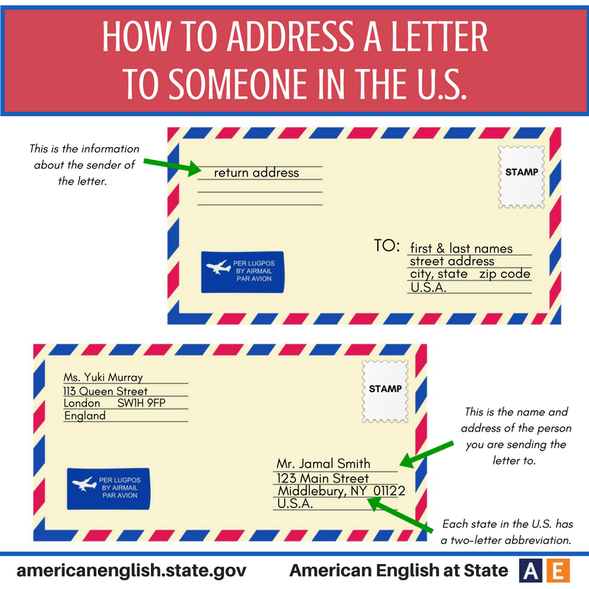

**Exercise 25**

**Match the information under a particular letter on the envelope (A, B, C, D, E, F, G) with what it indicates.**

|  |
| --- |
| (A) Cambridge School of Languages  119 (B) Mill Road  (C) Cambridge CB1 2 AZ  UK  (D) Newnham Language Centre  (E) 8 Grand Road  Oxford (F) OX 9DU  (G) UK |

1. The town the letter comes from
2. The Zip Code in the mailing address
3. The addressee’s house number
4. The country in the mailing address
5. The street name in the return address
6. The addressee
7. The sender

## Theme 1.2. Hobbies and Interests

### LEAD IN

**Work in pairs and explain how you understand this quotation:**

*“Try new hobbies. Develop new interests. Pursue new experience. When you expand your interests, you increase your opportunities for happiness”.*

*Richelle E.Goodrich.*

### KEY WORDS AND WORD COMBINATIONS

|  |  |  |
| --- | --- | --- |
| hobby (n) | ['hɔbɪ] | хобби, любимое занятие |
| to enrich (v) | [ɪn'rɪʧ] | обогащать |
| to prefer (v) | [prɪˈfɜː] | предпочитать |
| inner world (adj+n) | [ˈɪnə wɜːld] | внутренний мир |
| pastime (n) | [ˈpɑːstaɪm] | приятное времяпрепровождение |
| to collect (v) | [kəˈlekt] | собирать |
| to have a passion (v+n) | [hæv ɑ pæʃn] | увлекаться чем либо |
| occupation (n) | [ɒkjʊˈpeɪʃn] | профессия, род занятий |
| fascinating (adj) | [ˈfæsɪneɪtɪŋ] | увлекательный, чрезвычайно интересный |
| entertainment (n) | [entəˈteɪnmənt] | развлечение |
| to be in high spirits (v+ adj+n) |  | быть в хорошем настроении |
| to bring happiness (v+n) | [brɪŋ ˈhæpɪnɪs] | приносить счастье |
| to look forward (v) | [lʊk ˈfɔːwəd] | ждать с нетерпением |
| to improve ( v) | [ɪmˈpruːv] | улучшать |
| to stay focused on (v+part.+ prep) | [steɪ ˈfəʊkəst ɒn] | сконцентрироваться на чем-то |
| to master (v) | ['mɑ:stə] | совершенствовать |
| benefits (n) | ['benɪfɪts] | преимущества |
| rewarding (adj) | [rɪ'wɔ:dɪŋ] | приносящий внутреннее удовлетворение, дающий результат |
| skills (n) | [skɪls] | навыки, умения |
| sense of purpose (n+prep+n) | [sens ɒv ˈpɜːpəs] | целеустремленность |
| rare (adj) | [reə] | редкий |

### PRONUNCIATION PRACTICE

**Exercise 1**

**Practice saying the key words and word combinations.**

**Exercise 2**

**a.Choose the words with the stress on the first syllable:**

hobby, to collect, to enrich, inner, to prefer, spirits,entertainment,improve

**b.Say what parts of speech the words with the stress on the second syllable are.**

### VOCABULARY

**Exercise 3**

**Word builing.**

**a. Form nouns from the given verbs.**

|  |  |
| --- | --- |
| **Verb** | **Noun (suffix *-tion*)** |
| to motivate | motivation |
| to occupy |  |
| to collect |  |
| to satisfy |  |
| to translate |  |

**b. Complete the sentences with a noun formed from the verbs in (a):**

1. Hobby is a person's favorite _________, something that he likes doing in free time.
2. One can find great___________in a hobby.
3. Book lovers usually have large _________of books.
4. Some students do not have the__________ to study.
5. He hopes his _____ skills will help to understand foreign cultures.

**c. Form nouns from the verbs using *-ing* and translate them into Russian.**

|  |  |
| --- | --- |
| **Verb** | **Noun + (*-ing*)** |
| 1. to write | writing |
| 1. to learn |  |
| 1. to walk |  |
| 1. to collect |  |
| 1. to paint |  |
| 1. to watch |  |

**Exercise 4**

**Match the synonyms.**

|  |  |
| --- | --- |
| 1. pastime | 1. work |
| 1. purpose | 1. advantages |
| 1. occupation | 1. hobby |
| 1. benefits | 1. happiness |
| 1. well being | 1. goal |

**Exercise 5**

**Match the antonyms.**

|  |  |
| --- | --- |
| 1. important | 1. busy |
| 1. free | 1. outer |
| 1. inner | 1. widespread |
| 1. high | 1. old |
| 1. fascinating | 1. unimportant |
| 1. rare | 1. boring |
| 1. new | 1. low |

**Exercise 7**

**a. Make up all possible word combinations.**

|  |  |
| --- | --- |
| 1. to have | 1. in high spirits |
| 1. to be | 1. happiness |
| 1. to improve | 1. a passion for |
| 1. to bring | 1. time |
| 1. to spend | 1. skills |
| 1. to master | 1. joy |
|  | 1. satisfaction |

**b. Complete the sentences with the word combinations from (a):**

1. Sport helps me __________.
2. A hobby also gives __________.
3. Hobbies motivate us to learn more and ______our_____.
4. A person who likes computer games has __________them.
5. This pastime ____me much ______.
6. Hobbies help a person to feel happy and _________with pleasure.

**Exercise 8**

**a.Match the word combinations with their Russian equivalents.**

|  |  |
| --- | --- |
| 1. to enrich the inner world | 1. сосредоточиться на целях |
| 1. to have a passion for learning languages | 1. коллекционировать редкие (необычные) вещи |
| 1. to become a harmoniously developed person | 1. увлекаться изучением языков |
| 1. to stay focused on goals | 1. приносить счастье |
| 1. to collect rare items | 1. обогатить внутренний мир |
| 1. to bring happiness | 1. стать гармонично развитой личностью |

**b.Make your own sentences with the word combinations from (a).**

### GRAMMAR I

**Study grammar rules on the use of the verb TO HAVE (see GRAMMAR REFERENCE pp.92)**

**Exercise 10**

**Open the brackets using the correct form of the verb “to have”. Translate the sentences.**

1. On weekdays I (don’t / doesn’t) have much free time.
2. My father (have / has) two sisters.
3. (Do / Does) your friend have any brothers or sisters?
4. First year students (have / has) lectures and seminars.
5. (Do / Does) you have a hobby?
6. Does your sister (have / has) free time on Saturdays?

**Exercise 11**

**a. Make questions for the answers.**

1. I don’t have much free time on weekends.
2. Our University has a cyber zone.
3. Tom has a brother and two sisters.
4. We have relatives in Kazan.
5. My friend has a small dog.
6. I have a very rare hobby.

**b. Work in pairs. Ask your groupmates questions using the verb “to have”.**

### READING

**Exercise 12**

**Read the text and give it a title.**

Having a hobby is an important part of life. It is a way to relax, have fun and learn new things. A hobby can be anything that you enjoy doing in your free time. Some people like collecting things, such as stamps, books or coins. Others enjoy entertainments, like watching movies or listening to music. One is fond of extreme sports like snowboarding or parachuting.

There are many fascinating hobbies to choose from. Some people prefer gardening, while others have a passion for learning languages or playing computer games. Whatever you are interested in, there is always a hobby that suits you.

A hobby helps us to become harmoniously developed persons, enrich our inner world and bring happiness into our lives, and make friends sharing the same intrests.It is also a great way to spend our time productively and be in high spirits. Hobbies motivate us to learn more and improve our skills.

One great thing about having a hobby is that it can provide a sense of purpose. It gives us something to look forward to and helps us stay focused on our goals. Whether it's collecting rare items or mastering new skills, a hobby can be a rewarding occupation.

I believe hobby is essential for our well-being. It brings joy and satisfaction into our lives and helps us stay motivated. So why not to take a hobby that makes us happy and creative and start enjoying life benefits right now?

**Exercise 13**

**a.Answer the questions:**

1. Why is having a hobby important?
2. What hobbies do people usually enjoy?
3. Can a hobby help us stay motivated? If so, how?
4. What are the benefits of having a hobby?

**b.Find nouns in the text that are formed from the verb with *-ing*. Translate them into Russian.**

**c.Say what hobbies you have or would like to have.**

**Exercise 14**

**Finish the sentences using information from the text:**

1. Having a hobby is ________.
2. Some people like _________________.
3. Watching movies or listening to music are______.
4. Snowboarding or parachuting are__________.
5. Hobby helps us____________.
6. A hobby is_____________.

**Exercise 15**

**Prove the following statements using information from the text.**

1. Hobbies can be different.
2. Some people prefer entertainments.
3. Some hobbies are extreme.
4. You can always find a hobby you enjoy.
5. Having a hobby makes your life more organised.

### GRAMMAR II

**Study grammar rules on the use of the “VERB + -*ING* form” (see GRAMMAR REFERENCE p.93)**

**Exercise 16**

**a.Study the list of the activities. Say what you like or dislike doing. Give your reasons.**

***Model:*** *watching movies — I like watching movies.*

1. going to theatres
2. playing computer games
3. visiting other countries
4. eating out
5. reading
6. surfing the internet
7. having picnics

**b. Read the statements with synonyns for like and dislike. Agree or disagree with the statements (see theme 1.1. for phrases of agreement and disagreement)**

1. **I avoid** showing my feelings.
2. **I can't stand** cooking.
3. **I** **love** finding solutions to problems.
4. **I enjoy** helping people.
5. **I don’t mind** listening to people’s problems.
6. **I’m interested in** making websites.
7. **I dislike** writing letters.
8. **I hate** meddling with other people affairs.
9. **I’m keen on** playing volleyball.
10. **I’m crazy about** shopping.

**c.How do you feel about these things? Use phrases from b.**

***Model:*** haveparties — I love having parties.

|  |
| --- |
| *learn about computers, watch movies, listen to rock music, walk in a rainy weather, go clubbing, write letters, chat on the phone.* |

**d.Work in pairs. Make a list of your likes and dislikes and exchange information with your groupmates.**

### LISTENING

**Exercise 17**

**You are going to watch a video. It is a dialogue between two students about their hobbies at**

[**https://www.youtube.com/watch?v=-UX0X45sYe4**](https://www.youtube.com/watch?v=-UX0X45sYe4) **(Accessed: 31** August2023**).**

**BEFORE YOU WATCH. Answer the question:**

1. Do you have any interesting hobbies?
2. What kind of hobbies do you enjoy doing?
3. Why do you think it's important to have hobbies?

**b.WHILE YOU WATCH. Listen and complete the summaries of their talks. Use the following words and word combinations:**

|  |
| --- |
| *pastime; stamps; hobbies; science; to collect things; to go to those countries; to have a stamp; to read; all over the world; especially**like* |

I have several _____ . I do like _____ . I like to collect __ . I collect stamps from ___ because I hope ____ from every country. I think I won’t be able ___ myself.

I like ___ a lot. I like to read about _____ . I ____ to read about nature and electronics. I think this …_____ exercises my brains.

**c.AFTER YOU WATCH. Make up your own dialogues using the expressions from the video.**

### GRAMMAR III

**Exercise 18**

**You are going to watch a video “Street talk with Emi K” at** [**https://www.youtube.com/watch?v=ijewO__atOc**](https://www.youtube.com/watch?v=ijewO__atOc)

**a.WHILE YOU WATCH. Listen and complete the summaries.**

1. Today'squestion is, what _____(1) you _____(2) these days?
2. I ___(2)____a lot of thing these days.
3. I___(3)_____to drive.
4. I___(4)_____tennis lessons.
5. I ___also (5)_____a good book.
6. I______(6)_______French.
7. I______(7)_______English here for a month.
8. I _____(8)_______in a lot of great restaurants.
9. I______(9)_____a lot of shopping,too.
10. I_____(10)____ready for a trip to Brazil.

**What grammar construction does Emi and the people she interviews use? What does this grammar construction consist of?**

**Check your answer in Grammar Reference (see Grammar Reference p.93).**

**b.Review the rule for using the Present Progressive (Continuous) Tense, read the sentences. Match the sentences with grammar rules and explain the use of this construction to your groupmates. In case of difficulty, refer to the Grammar Reference.**

|  |  |
| --- | --- |
| 1. She is doing her homework while I am drinking coffee. | 1. A change that has started to happen. |
| 1. We are moving into a new house. | 1. The situation is temporary. |
| 1. He is staying in Kazan for three months. | 1. The action takes place now but is not limited to the present moment. |
| 1. Your English is getting better. | 1. Speech is emotionally coloured, the speaker is annoyed or displeased. |
| 1. Next week we are buying a new car. | 1. The action is happening right now, at the moment. |
| 1. You are always interrupting me! | 1. The action is planned and certain to take place in the near future. |

**c.Complete the rule for the Past Progressive and Future Progressive Tense.**

|  |  |
| --- | --- |
| **Past** | **Future** |
| I/She/He __________ French.  We/they/you ____________English. | I/She/He/they/you/we ___ be _____ English. |
| I _____not____French.  We_____not____English. | I/She/He/they/you/we ___ not be _____ English. |
| ______you____English  What ___ they _____? | ____ I/She/He/they/you/we be ____ French? |

**Exercise 19**

**a.Make sentences from the given words in 3 tenses (Present Progressive, Past Progressive, Future Progressive:**

to drive/ they/ to Moscow;

to watch/I/TV;

pizza/to cook/ Alex;

to rain/it;

to do homework/Helen;

Tom/hard/not/to work;

to learn/ French/I.

***Model:*** to drive/ they/ to Moscow.

|  |  |
| --- | --- |
| **Present Progressive** | ***They are driving to Moscow right now.*** |
| **Past Progressive** | ***They were driving to Moscow yesterday.*** |
| **Future Progressive** | ***They will be driving to Moscow at this time tomorrow.*** |

**b.Put the verbs in brackets in the correct form (Present, Past or Future Progressive):**

1. Please don’t make so much noise. I (to try) to work.
2. The first year students (not to take) a test next week.
3. Andrew started evening classes recently. He (to learn) Japanese.
4. We (to play) computer games the whole evening.
5. My family and I (to chat) on the phone tomorrow
6. The climate (to get) warmer.
7. It (to rain) the whole day yesterday.
8. While Alan (to work) in his room, his friends (to swim) in the pool.
9. She (to live) with her grandparents.
10. I tried to tell them the truth but they (not to listen).

**c. Ask questions to the sentences from b.**

**Exercise 20**

**Answer the questions:**

1. Are you having an English class?
2. When do you usually have English classes?
3. Are you learning to drive?
4. Is your best friend learning English?
5. Are you studying Engineering?
6. What are you reading at the moment?
7. Where were you living at the start of the year?
8. What will you be doing at this time tomorrow?

### SPEAKING

**Exercise 21**

**Make your own similar ”Street talk” dialogues (see Ex.18) and present them with your partner.**

### WRITING

**Exercise 22**

**Writing informal letter.**

**a. Read Informal Letter sample.**

*INFORMAL LETTER SAMPLE*

|  |
| --- |
| *Address (1)*  *September 23,2023 (2)*  *Dear Alex (3),*  *(4)I am very happy to introduce myself to you. My name is Egor Petrov. I live in Moscow, Russia. Would you like to be pen pals with me? We can write letters to each other and practice Engish.*  *I am seventeen years old. My hobbies are swimming, basketball, and music. I study at the Russian Technological University MIREA and I am going to be a computer programmer. My father is a robotics engineer, and my mother is a systems analyst. I have one sister. She is a pupil at school.*  *Is your family large? Do you have any brothers or sisters? Are you a student? Do you have any hobbies? Please write and tell me about yourself. Maybe someday we can visit each other.*  *(5)Sincerely,*  *(6) Egor Petrov* |

**b. Study the rules of writing informal letters**:

In the informal letter format, your address, date, the closing, signature, and printed name are all indented to the right half of the page. Also the first line of each paragraph is indented.

1. Your Address: (Not needed if the letter is printed on paper with a letterhead already on it.): Write your street address on the first line and the city, state and zip on the second line.
2. Date: Put the date on which the letter was written in the format Month Day Year i.e. August 30, 2003. Skip a line between the date and the salutation.
3. Salutation: Start out with “Dear … and …”, or “Hi … and …”. Note: There is a comma after the end of the salutation (you can use an exclamation mark also if there is a need for some emphasis).
4. Body: The body is where you write the content of the letter; the paragraphs should be single spaced with a skipped line between each paragraph. Skip 2 lines between the end of the body and the closing.
5. Closing: Let the reader know that you finished your letter; end with “Sincerely”, “Sincerely yours”, “Thank you”, and so on. Note that there is a comma after the end of the closing and only the first word in the closing is capitalized.
6. Signature: Your signature will go in this section, usually signed in black or blue ink with a pen. Skip a line after your signature and the P.S.

(Adapted from: <https://www.studynlearn.com/blog/informal-letter-format/>)

**c. Use Informal Letter Sample from a. and write a letter to your friend.**

## Theme 1.3. Life Stories

### LEAD-IN

**Work in pairs. Choose the quote and explain how you understand it:**

1. *"Life is like riding a bicycle. To keep your balance, you must keep moving."*

*Albert Einstein*

2. *“Everyone is necessarily the hero of his own life story.”*

*John Barth*

### KEY WORDS AND WORD COMBINATIONS

|  |  |  |
| --- | --- | --- |
| acquired skills | [əˈkwaɪəd skɪlz] | приобретенные навыки |
| cheerful and positive attitude | [ˈʧɪəfʊl ənd ˈpɒzətɪv ˈætɪtjuːd] | радостный и позитивный настрой |
| contribute significantly | [kənˈtrɪbjuːt sɪɡˈnɪfɪkᵊntli] | сделать значительный вклад |
| equipment | [ɪˈkwɪpmənt] | оборудование |
| great sense of humor | [ɡreɪt sɛns əv ˈhjuːmə] | отличное чувство юмора |
| highest score | [ˈhaɪɪst skɔː] | высший балл |
| highly-educated | [ˈhaɪli-ˈɛʤʊkeɪtɪd] | высокообразованный |
| humanity | [hjuːˈmænəti] | человечность |
| merchant | [ˈmɜːʧᵊnt] | купец/торговец |
| native wit | [ˈneɪtɪv wɪt] | врожденное остроумие |
| secondary education | [ˈsɛkəndəri ˌɛʤʊˈkeɪʃᵊn] | среднее образование |
| staff | [stɑːf] | сотрудники |
| stringent requirements | [ˈstrɪnʤᵊnt rɪˈkwaɪəmənts] | строгие требования |
| to be engaged in | [tə bi ɪnˈɡeɪʤd ɪn] | быть вовлеченным в |
| to pass away | [tə pɑːs əˈweɪ] | скончаться |
| to surround | [tə səˈraʊnd] | окружать |
| transmitting and receiving information | [trænzˈmɪtɪŋ ənd rɪˈsiːvɪŋ ˌɪnfəˈmeɪʃᵊn] | передача и получение информации |
| vivid example | [ˈvɪvɪd ɪɡˈzɑːmpᵊl] | живой пример |
| wealthy | [ˈwɛlθi] | богатый |
| wisdom | [ˈwɪzdəm] | мудрость |

### PRONUNCIATION PRACTICE

**Exercise 1**

**Practice reading key words and word combinations.**

**Exercise 2**

**Read international words and translate them.**

|  |
| --- |
| *dissertation optimist extravert construction experiment seminary to demonstrate colleague laboratory talent gymnasium faculty to publish privilege* |

**Exercise 3**

**Match the word with their Russian equivalents.**

|  |  |
| --- | --- |
| 1. contemporaries | 1. бакалавриат |
| 1. talent of a good public speaker | 1. современники |
| 1. undergraduate course | 1. электромагнитные волны |
| 1. PhD degree | 1. ораторский талант |
| 1. electromagnetic waves | 1. степень кандидата наук |

**Exercise 4**

**a. Make up word combinations and translate them into Russian.**

|  |  |
| --- | --- |
| 1. to make | 1. one’s passion for |
| 1. to get | 1. a thesis |
| 1. to be | 1. comfortable in new surroundings |
| 1. to awake | 1. ends meet |
| 1. to submit | 1. pretty easy to talk to |

**b. Complete the sentences with the words from a) using the necessary tense form.**

1. My father ________ my ________ cars and mechanics.
2. What a pleasant young man! He ___________.
3. They were poor and barely __________.
4. I’m an extravert and it is easy for me __________.
5. Ivan is a postgraduate and __________ next summer.

### VOCABULARY I

**Exercise 5**

**Explain these personality traits.**

|  |
| --- |
| *experienced capable romantic passionate wise serious talented witty* |

***Model:*** A romantic person is the kind of person who enjoys dreaming and has a lot of ideas which don’t relate to the real life.

1. to give good advice and make good decisions.
2. to have some natural ability to do something.
3. to be able to do something effectively and skillfully.
4. to enjoy dreaming and have a lot of ideas which don’t relate to the real life.
5. to know many things about something.
6. to give things a lot of thought.
7. to dedicate one’s life to only one thing and do everything to achieve results.
8. to speak in a clever and amusing way.

**Exercise 6**

**Look at the adjectives for discussing people and match them to the definitions.**

1. Outgoing
2. Confident
3. Warm-hearted
4. Old-fashioned
5. Sarcastic
6. Boastful
7. Determined
8. Timid
9. Energetic
10. Single-minded
    1. usually talking about or making obvious your own abilities and achievements too proudly
    2. not modern; belonging to or typical of a time in the past
    3. lacking in courage or self-confidence
    4. openly friendly and responsive
    5. only doing things that relate to one activity or interest
    6. marked by ready affection, cordiality, generosity, or sympathy
    7. very active physically and mentally
    8. being certain of your abilities or having trust in people, plans, or the future
    9. wanting to do something very much and not allowing anyone or any difficulties to stop you
    10. having the character of sarcasm

**Exercise 7**

**a. Match these words with the words with similar meanings.**

|  |  |
| --- | --- |
| 1. trustworthy | a) reserved |
| 1. upbeat | b) reliable |
| 1. introverted | c) honest |
| 1. humble | d) cheerful |
| 1. sincere | e) modest |

**b. Give your own examples of similar adjectives.**

**c. Choose one adjective from (a) to describe each of the following people.**

**Exercise 8**

**a.Match these words with their opposites**

|  |  |
| --- | --- |
| 1. introverted | a) unsociable |
| 1. shy | b) boring |
| 1. gregarious | c) quiet |
| 1. talkative | d) extraverted |
| 1. fun | e) friendly |

**b. Give your own examples of opposite adjectives.**

**c. Choose one adjective from (a) to describe each of the following people.**

***Model:*** Jack likes other people. He is always behaving in a pleasant and kind way towards them. – Jack is friendly.

1. Kate doesn’t like being alone. She likes visiting crowded places.
2. It is interesting to be around Jill. She knows many jokes and is always ready to try something new.
3. Boris doesn’t usually talk much.
4. Dorothy likes to talks to anyone who is ready to listen to her. It is very difficult to make her stop talking.
5. Keith avoids people. When he has to be with people, he feels uncomfortable.

### GRAMMAR REVISION. SIMPLE AND PROGRESSIVE TENSES

**Exercise 9**

**Choose the correct form in italics.**

1. My parents *are/is* visiting me next week.
2. He *listens/is listening* to music in his free time.
3. The movie *is starting/starts* in a few minutes.
4. I *have/has* a pet dog named Max.
5. My sister *is/am* reading a book in her room.
6. I *am wearing/was wearing* a blue shirt today.
7. He *works/worked* as a teacher.
8. The sun *is shining/shines* brightly.
9. We *often eat/are often eating* dinner together.
10. The movie *starts/will start* at 7:30.

**Exercise 10**

**Open the brackets and put the verbs into Simple or Progressive forms.**

1. He (to enjoy) ________ playing the guitar.
2. He (not to listen) ________ to music while studying.
3. Cats (to sleep) ________ on the couch at the moment?
4. She (not to walk) ________to university every day.
5. I (not to watch) ________ TV yesterday morning.
6. The store (to open) ________ at 9 am?
7. My sister (to read) books before bed.
8. The bus (to arrive) ________ late yesterday?
9. The sun (to rise) ________ in the east.
10. I (to have) ________ a cup of tea.

**Exercise 11**

**Translate the sentences from Russian into English**

1. Чтобы видеть четко, я ношу очки.
2. Птицы не щебечут на деревьях.
3. Они пьют по утрам кофе?
4. Прямо сейчас она плавает в бассейне.
5. Автобус прибывает в 8 часов?
6. Он работает над новым проектом?
7. Сегодня магазин не закрывается рано.
8. Каждую субботу Том играет в футбол.
9. В этом месяце мои родители проживают во Франции.
10. Ей нравится плавать в океане?

### LISTENING

**Exercise 12**

**Watch the video on how people describe their personalities at** [**https://www.youtube.com/watch?v=gMU9tk7fhQI**](https://www.youtube.com/watch?v=gMU9tk7fhQI)**.**

**a. BEFORE YOU WATCH. Answer the preliminary questions:**

Is it easy to characterize yourself?

Is there any difference in how the other people see us and how we see ourselves?

**b. WHILE YOU WATCH. Listen to how three speakers characterize themselves. Fill in the gaps using the words from the video.**

1. _________ , I guess, some people would describe me as. I’m very ________. I will basically talk to anybody about anything, if they ask me.
2. [It] Takes me a little while to get comfortable in new ________. But then once I’m comfortable, I kind of ________ and I’m OK.
3. They see me a little more ________ than I feel inside. But overall, no, I think they see me as a very ________, trustworthy person.
4. I’m generally a happy person. I try to stay ________ and not let that much get me down, and I’m very ________.
5. Just walking down the street you meet new people and friends, and things like that. So, yeah, pretty ________ in general.
6. I probably see myself a little bit ________ than other people see me, but only in terms of, [be]’cause I know my ________ and people just see what they see, you know.
7. I am very outgoing. I’m . . . fun. I’m very ________. And . . . gosh . . . I’m . . . sometimes I can be ________.
8. I think I have a lot of ________ that an outgoing person would have, but I also have qualities that maybe a ________ person would have, so it kind of balances me out.
9. Sometimes it depends on the environment; sometimes I’m ___ ___ ____, other times I’m a little more ________.

**c. AFTER YOU WATCH. How would you characterize yourself? Tell your groupmates a couple of words about your personality.**

**Exercise 13**

**Watch the video about some colloquial English phrases used to describe personalities at** [**https://www.youtube.com/watch?v=m1BsepAo854**](https://www.youtube.com/watch?v=m1BsepAo854)**.**

**a. BEFORE YOU WATCH. Answer the preliminary questions:**

Do you understand English slang? Internet slang? Do you encounter it often in your everyday life?

**b. WHILE YOU WATCH. Listen to Hannah and explain what these words from the video mean.**

1. Klutz
2. Homebody
3. Arrogant

**c. AFTER YOU WATCH. Try to remember what colloquial words or phrases you know. Share some useful words and phrases with your groupmates.**

### VOCABULARY II

**Exercise 14**

**Write the numbers. Read them aloud.**

|  |  |  |  |
| --- | --- | --- | --- |
| two – 2 | 56 – | 14 – | 5 607 – |
| eleven – | 400 – | 601 – | 19 – |
| one thousand – | 342 – | 690 – | 509 – |
| 3 – three | 677 – | 212 – | 782 – |
| 17 – | eight hundred and twelve – | seven – | two hundred – |
| 67 – | six hundred and ninety-nine | eighty-seven – | two thousand one hundred and thirty-two |
| 12 – | two hundred and eleven – | zero – | a billion – |
| 29 – | three thousand and one – | 1 000 000 – | 1 005 – |

**Exercise 15**

**Number dictation. Work in pairs. Write down 10 numbers. Dictate them to your groupmate**

**Exercise 16**

**a. Read the dates. What happened on these dates?**

A. 2 November 1721

B. 27 June 1954

C. 12 April 1961

D. 9 May 1945

E. 25 December 1993

F. 6 June

**b. Make your own list of dates. Let your groupmates guess what happened on them**.

**Exercise 17**

**Some numbers and dates in the sentences are false. Correct them.**

1. A fly has 5 eyes.
2. Ivan Petrovitch Pavlov died on 17 December 1936.
3. They opened The Crimean Bridge for motor vehicles on 16 May 2018.
4. There are two suns in the Solar System.
5. Yuri Dolgoruky founded Moscow in 1147.
6. Dmitry Mendeleev presented the first variant of his Periodic Table on 27 March 1869.

**Exercise 18**

**a. Study the rule about prepositions.**

|  |  |  |
| --- | --- | --- |
| **at** | Time: 10:11, midnight, lunchtime  Holiday time: Christmas, Thanksgiving  Also: night, the weekend, the beginning/end, moment | **Used for times and special holiday periods** |
| **on** | Day: Tuesday  Part of specific day: Friday morning  Date: 14 July  Special day: Victory Day | **Used for specific days and parts of specific days** |
| **in** | Month: January  Year: 2022  Season: the winter  Part of the day: the morning, the evening | **Used for long periods of time** |

**b. Write *at/on/in***

1. Let’s meet __ Monday!
2. My brother graduated __ June.
3. Alexander I was born __ 23 December 1777.
4. Parents gave him a present __ Christmas Eve.
5. Do you attend your English classes __ Sundays?
6. I went to Siberia __ winter.
7. I love listening to music __ Saturday evening.
8. I woke up __ 8 o’clock __ the morning.

### READING

**Exercise 19**

**Split into two groups. Group A reads Text A, Group B reads Text B. After reading, tell you groupmates from another group about a person from the text.**

*Text A*

*ALEXANDER STEPANOVICH POPOV, THE INVENTOR OF RADIO*

Alexander Stepanovich Popov was born on March, 16, 1859 in the village of Turinsky mines, named after the river Turya (in the Northern Urals).

A. S. Popov (1895-1906)

The most exciting game for him and his friends was building constructions, similar to those that surrounded him in his childhood. Acquired skills from childhood to do everything with his own hands turned out to be useful later. As a student he liked installation work and then he himself made the necessary equipment for the experiments.

The Popovs had a large family with seven children. They barely made ends meet, so A. S. Popov attended a religious school (1869), and then a seminary, which gave a full course of secondary education, where he could study for free.

He received the highest score in all subjects and entered the St. Petersburg University on August 31, 1877 without exams. Due to his knowledge, as well as for the submitted thesis, he was found worthy of the PhD degree in Physics and Mathematics, awarded to him by the Council of the University on November 29, 1882.

In 1883 A. S. Popov started to work as a physics teacher in the Mine Officer Class in Kronstadt. Having become interested in Hertz’s experiments with electromagnetic waves, he perfected them by applying for transmitting and receiving information. On May, 7, 1895, he demonstrated his experiments publicly, that is why May, 7 is the birthday of radio.

The first radio receiver by A. S. Popov (1895)

His colleagues and contemporaries said that Alexander Popov was a brilliant and single-minded scientist. He spent all his spare time in his laboratory testing various theories and trying to make them better. He knew no rest and holidays. He was so passionate about what he did. Also, he was shy and timid, especially when he gave his public lectures. He lacked the talent of a good public speaker. He never promoted himself because of his inborn humbleness and modesty.

Alexander Stepanovich Popov died on January, 13, 1906. However, he had lived a short but amazing life of a scientist and an inventor, presenting his great invention – the Radio.

Blokhin A. V. Alexander Stepanovich Popov the Inventor of Radio / Blokhin A. V. // Ural Radio Engineering Journal. — 2017. — Vol. 1, No. 1. — P. 8-24.

*Text B*

*PROFESSOR ANDREI NIKOLAIEVITCH TIKHONOV*

Andrei Nikolaevitch Tikhonov was born on Tuesday, October 30, 1906, in the town of Gagarin (previously Gzhatsk), in Smolensk region (West Russia) into a wealthy family. His father was a merchant. His mother was warm hearted, capable and energetic. She took care of their two sons, who grew up together and got the best education.

A. N. Tikhonov's family in 1910: From left to right: Mariya Nikolaevna (his mother), (2) Nikolai (his brother), (3) Andrei N. Tikhonov (4 years) and (4) his father Nikolai Vasilyevich.

In 1910 the Tikhonovs moved to Moscow, where the boys visited a city's gymnasium. When A. N. Tikhonov was 15 (in 1922), he went on to study at the Mathematics Department of Moscow State University of Faculty of Physics and Mathematics.

He published his first paper in 1925 while he was still 19, and in the middle of his undergraduate course. Tikhonov earned his PhD. in 1927 under the supervision of P. S. Aleksandrov, who was only ten years older.

On the left, A. N. Tikhonov at age of 18. On the right, A. N. Tikhonov at age of 40.

After successfully defending his thesis in 1936, Tikhonov was appointed as a professor of Moscow State University. A year later, in 1937, he was appointed the head of the Department of Mathematics of the Moscow State University Faculty of Physics. Tikhonov and his team contributed significantly to establishing and developing important tools used in modern mathematical physics. Also, he was the founder and the Dean of the Faculty of Computational Mathematics and Cybernetics of the Moscow Lomonosov State University from 1970 through 1990.

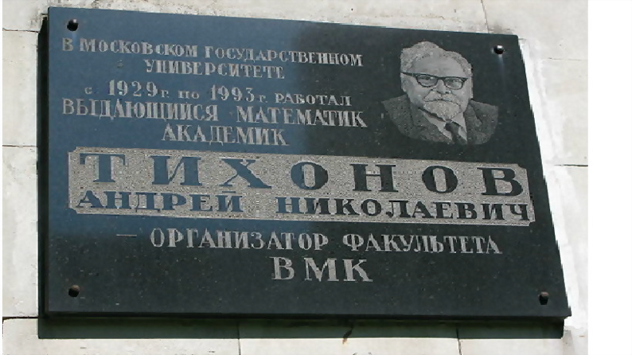Professor A. N. Tikhonov passed away on November 8, 1993. Tikhonov was a vivid example of a talented personality devoted to mathematics, physics, and science, and the development of research and his country. It was a privilege to work alongside him. His seriousness, determination, and at the same time, stringent requirements on science and the work of his staff created a very special atmosphere at the institute. He always spoke with a cheerful and positive attitude. At the same time, he had a native wit, wisdom, humanity, self-irony, and a great sense of humor.

Hayat Rezgui, "In Memory of Professor Andrei Nikolaievitch Tikhonov (1906-1993) on the 25th Anniversary of His Death," Journal of Humanistic Mathematics, Volume 8 Issue 1 (January 2018), pp. 332-349.

**Exercise 20**

**Answer the questions on the text A.**

1. What was A. S. Popov? Where was he born?
2. What was his biggest passion when he was a child?
3. What can you say about Popov's family? How did it influence his education?
4. How did he enter the university?
5. Did he manage to get a PhD degree?
6. What did he invent?
7. How did the A. S. Popov’ s contemporaries characterize him?

**Exercise 21**

**Answer the questions on the text B.**

1. What was A. N. Tikhonov? Where was he born?
2. What can you say about his family?
3. When did A. N. Tikhonov go to study at Moscow State University?
4. When did he publish his first paper?
5. How old was he when he got a PhD degree?
6. What big project did he participate in?
7. How did A. N. Tikhonov’s colleagues characterize him?

### SPEAKING

**Exercise 22**

**a. Look at the timeline and say what events in the life of A. S. Popov it reflects**

1859; 1869; 1877; 1882; 1895; 1906

**b. Look at the timeline and say what events in the life of A. N. Tikhonov it reflects**

1906, 1910, 1922, 1925, 1927, 1937, 1970, 1993

**c. Make a timeline about your life. Include one false thing. Use the following words and expressions:**

*was born, went to kindergarten, started school, met my best friend, went on holiday to…, won a competition, was admitted to…, started to attend*

**d. Work in pairs. Use your timeline and tell your partner about your life. Guess the false information.**

Model: A: I started school when I was 6

B: False.

A: True. I really started school when I was six. I am seventeen now.

### WRITING

**Exercise 23**

**Write a short biography of a famous person. Read it to your groupmates but do not mention the person’s name. Let the others guess the person you wrote about.**

# UNIT 2. Higher Education in Russia and Abroad

### LEAD IN

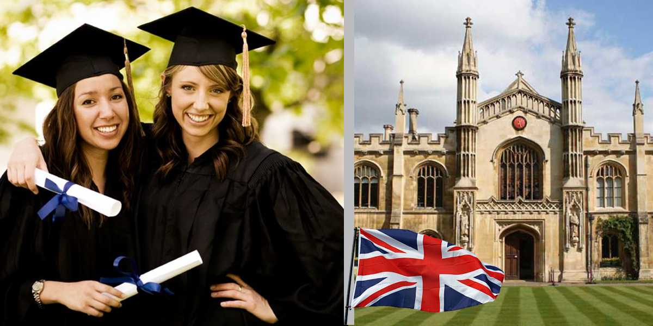

**Work in pairs and explain how you understand this quotation:**

*"I cannot teach anybody anything, I can only make them think."*

*Socrates*

## Theme 2.1. Higher Education in Great Britain

### KEY WORDS AND WORD COMBINATIONS

|  |  |  |
| --- | --- | --- |
| to be referred to as | [biː rɪˈfɜːd tuː æz] | называться |
| academic research | [ækəˈdemɪk rɪˈsɜːʧ] | научное исследование |
| to enter | [ˈentə] | поступить |
| to enrol in (US enroll) | [ɪnˈrəʊl ɪn] | поступить, записаться |
| to complete | [kəmˈpliːt] | получить, завершить |
| bachelor’s degree | [ˈbæʧələ’es dɪˈgriː] | степень бакалавра |
| to award | [əˈwɔːd] | присвоить. присудить |
| vocational | [vəʊˈkeɪʃnəl] | профессиональный |
| FE (Further education) college | [ˈfɜːðə edjʊˈkeɪʃn ˈkɒl.ɪdʒ] | колледж профессионального образования |
| apprenticeship | [əˈprentɪsʃɪp] | ученичество, стажировка |
| experience | [ɪksˈpɪərɪəns] | опыт |
| to apply for (to) | [tuː əˈplaɪ fɔː] | подать заявление, записаться |
| to pursue | [pəˈsjuː] | учиться с целью получения новой степени или знаний |
| academic achievements | [ækəˈdemɪk əˈʧiːvmənts] | академическая успеваемость |
| postgraduate | [pəʊstˈgrædjʊɪt] | аспирант, лицо, имеющее базовое высшее образование |
| conversion course | [kənˈvɜːʃn kɔːs] | курс переподготовки |
| sandwich course | [ˈsænwɪʤ kɔːs] | курс, совмещающий теорию и практику |
| term | [tɜːm] | семестр |
| employment | [ɪmˈplɔɪmənt] | трудоустройство |
| Master’s course | [ˈmɑːstə’es kɔːs] | магистратура |

### PRONUNCIATION PRACTICE

**Exercise 1**

**Practice saying the key words and word combinations.**

**Exercise 2**

**Choose the words with the stress on the second syllable:**

degree, bachelor, engineering, support, vocational, research, course, completion.

**Exercise 3**

**a. Remember the reading rule and read the words below:**

|  |  |
| --- | --- |
| **С** | |
| [s] only before *e*, *i*, *y* | [k] |

completion, necessary, experience, course, vocational, apprenticeship

**b. Remember that there are silent letters in English and read the words:**

high, choice, *k*nown, trainin*g*, offer, research.

**Exercise 4**

**Study word-building rules.**

1. **Nouns**

|  |  |
| --- | --- |
| **Suffix** | **Examples** |
| -er, -ee, -or, -ant/-ent, -ist | teacher, engineer, employee, degree, professor, educator, applicant, assistant, scientist |
| -ment, -ation, -(s)ion, -age, -ance,  -ing | employment, entertainment, examination, profession, importance, training |

**Compound nouns**

|  |  |
| --- | --- |
| **Scheme** | **Examples** |
| noun + noun, noun + verb, adjective + noun, verb + preposition/ adverb | website, network, classmate, dishwasher, dressmaker, high school, know how |

**Complete the sentences with a noun formed from the word in brackets.**

1. The university sends a ready studying invitation to the______. (to apply)
2. Our main task is to provide the students with useful______ about universities. (to inform)
3. I had no secretary or______. (to assist)
4. We currently provide ______ to 17 young professionals. (to employ)
5. For more information, please visit our _____. (… + site)

**b. Verbs**

|  |  |
| --- | --- |
| **Suffix** | **Examples** |
| **-**ise/-ize, -(e)n, -(i)ate, -(i)fy | specialize, organize, broaden, listen, communicate, classify, qualify, notify |
| **Prefix** | **Examples** |
| re-, dis-, over-, un-, mis-, out | rewrite, retell, reopen, dislike, disagree, oversee, unpack, misunderstand, outgrow, oversleep |

**Complete the sentences with the suitable form of a verb.**

1. This is the reason I _____with you. (do not agree)
2. How do computers _______ on a local network? (communication)
3. We _____ in this area and offer a wide range of products. (specialization)
4. Does that mean that I don't____as a programmer? (qualification)
5. I am glad that our library has _____ and I can get books and magazines again. (to open)
6. My friend told me a very interesting story, but I can’t _____ it, I don’t remember all the facts. (tell)

**c. Adjectives and adverbs**

|  |  |
| --- | --- |
| **Suffix** | **Examples** |
| -al, -ful, -less, -able, -y, -ous, -ent,  -ive | vocational, practical, useful, careless, suitable, windy, famous, excellent, active |
| -ly | formally, typically |

|  |  |
| --- | --- |
| **Prefix** | **Examples** |
| dis-, un-, in-, -im, -ir-, il- | disloyal, unusual, incorrect, incomplete, impossible, irreplaceable, illegal |

**Compound adjectives**

|  |  |
| --- | --- |
| **Scheme** | **Examples** |
| number + adjective, adjective + noun,  noun + adjective, ***self*** + verb/ adjective | two-hour, full-time, high-quality, user-friendly, well-paid, self- employed, first-year, well known |

**Complete the sentences with the suitable form of an adjective.**

1. I have_____Internet connection. (high / quality)
2. The purpose of_____ training is to equip people to lead active, productive, and satisfying lives. (vocation)
3. Real life gives you_____ skills. (practice)
4. This university attracts students from all over the world who seek to pursue____ courses. (to differ)
5. I worked for a very____ university. (well/know)

**Give opposites to these adjectives:**

popular, practical, friendly, formal, polite, logical, irresponsible, satisfied, useless.

**Exercise 5**

**Look through the text “Higher Education in the UK” (from Exercise 11) and find nouns formed with the following suffixes:**

|  |  |  |  |  |  |
| --- | --- | --- | --- | --- | --- |
| -ment | -or | -ion | -ing | -ee | -ship |
|  |  |  |  |  |  |

### VOCABULARY I

**Exercise 6**

**a. Match the abbreviations with their translations.**

|  |  |
| --- | --- |
| 1. BA degree | 1. степень магистра |
| 1. BSc degree | 1. степень бакалавра технических наук |
| 1. MA degree | 1. докторская степень |
| 1. PhD degree | 1. степень магистра в области исследовательской деятельности |
| 1. BEng | 1. степень бакалавра естественных наук |
| 1. MRes | 1. степень бакалавра |

**b. Match the words with similar meaning.**

|  |  |
| --- | --- |
| 1. vocational | 1. to obtain |
| 1. to complete | 1. to finish |
| 1. to gain | 1. qualification |
| 1. degree | 1. study |
| 1. training | 1. professional |
| 1. research | 1. useful |
| 1. valuable | 1. education |

**Exercise 7**

**a. Make up all possible word combinations.**

|  |  |
| --- | --- |
| 1. to apply | 1. a degree |
| 1. to gain | 1. the university |
| 1. to award | 1. an application form |
| 1. to provide | 1. for a place |
| 1. to enter | 1. a course |
| 1. to complete | 1. information |
| 1. to open up | 1. practical skills |
| 1. to pursue | 1. opportunities |

**b. Complete the sentences with the word combinations from (a). Put the verbs in the correct tense form if necessary.**

1. Last year, 2,500 students ________________.
2. In 1893 and 1894, Curie _______________in Physics and Maths respectively.
3. His first aim after school was _______Russian Technological______.
4. This section of the website ___________that will be useful to you.
5. After high school, Steven Spielberg tried_________ of Southern California.
6. Students have the opportunity not only to study theory but also __________.
7. You will need _____________, give two references and attend an interview.

### GRAMMAR I

**Study grammar rules on the use of** **Simple and Progressive (Continuous) Passive (see GRAMMAR REFERENCE p.95)**

**Exercise 8**

**Choose the correct variant in italics.**

1. Higher education in the UK *is provided/provides* by numerous universities and colleges.
2. Innovative programs *are being developed/develops* to enhance the quality of higher education.
3. The research project *was discussed/ is being discussed* by the research team at the moment.
4. Higher education in Great Britain *is offered/offers* a wide range of options for students.
5. The science lab *is renovated / will be renovated* over the summer break next year.
6. A new online learning platform *was used /will be used* by the university last year.
7. The exams *will be taken/will take* next week.

**Exercise 9**

**Put the words in brackets in the correct form.**

1. The term "university" ____ (to use) often interchangeably with "higher education institution" in the UK.
2. The homework _____ (to do) by the end of the week.
3. A bachelor's degree _____ (to award**)** after three years of studies.
4. London_____ (to know) for its beautiful architecture and art museums.
5. The students _____ (to teach) by a renowned professor in the lecture hall right now.
6. The pictures _____ (to take) during my vacation in Italy.
7. Basic education ______ (to provide) by the State free of charge.
8. The new language program _____ (to develop) by the language department for two months.
9. Oxford and Cambridge____ (to refer) to as Oxbridge.

**Exercise 10**

**Make sentences from the given words in 5 tenses (Present, Past and Future Simple Passive and Present and Past Progressive Passive:**

*do, cook, read, develop, answer, organize, translate.*

***Model:***

|  |  |
| --- | --- |
| *The Listening, Reading, and Writing tests are done on the same day.* | *More and more jobs are constantly being done by robots and computers.* |
| *The work was done professionally and quickly.* | *Lots of work was being done to improve the park.* |
| *The job will be done properly.* |  |

**Exercise 11**

**a. Translate sentences from Russian into English using Passive voice.**

1. В нашем университете постоянно разрабатываются новые курсы.
2. Существует множество методик, которые используются при обучении студентов инженерных специальностей.
3. По окончании курса присваивается степень "Бакалавр”.
4. Для студентов первокурсников будут организованы трехмесячные курсы английского языка.
5. К счастью, мы были подготовлены к подобной ситуации.
6. Курс «Искусственный интеллект» будет преподаваться на английском языке.
7. На этот вопрос правильно ответили все студенты.
8. Книга нашего преподавателя была переведена на английский язык и издана в прошлом году.
9. Студенты третьего курса прошли тестирование по техническим дисциплинам.
10. Для студентов первокурсников запланированы развлекательные мероприятия.

**b. There are Passives in the text (Ex.11). Find them and comment on their use.**

### READING I

**Exercise 12**

*HIGHER EDUCATION IN THE UK*

Education in the UK is high-quality and prestige. British universities have high graduate employment rates and good funding. The two most well-known universities are Oxford and Cambridge, which are often referred to as Oxbridge. These universities have a reputation for excellence in academic research and teaching because new course modules are constantly being developed and personalized teaching methods are continuously being used here.

In the UK, students enter the university after completing their secondary education. A bachelor's degree is awarded after three years of studies. Students have the choice of a number of courses to take, including vocational degrees, which prepare them for specific professions, or more general courses such as history or literature.

Further education (FE) colleges offer a range of courses, including vocational qualifications and apprenticeships. A lot of students who do not pursue a university degree choose to attend FE colleges to gain practical skills and experience. FE Colleges train IT, business, engineering, and healthcare support staff.

To enrol in university, students apply for a place through the UCAS* system. This involves completing an application form and providing information about their academic achievements and interests.

Undergraduate degree (BA, BEng) is an important milestone in a student's life, and it opens up many opportunities for future employment. Some educational institutions also provide conversion courses, which allow students to switch to a different field of study. Another popular option for students is a sandwich course, which involves a year of on job training between academic terms. This gives valuable practical experience and can help students to get employment after graduation.

After gaining their undergraduate degree, students may pursue a Master's course or a PhD, which requires further study and research. The duration of these courses is one year. Apart from MS in UK, other available degrees are MBA, MA, and MRes.

Higher education in Great Britain offers a wide range of options for students from vocational training to academic research. No wonder that students from all over the world opt for British universities.

***Notes:***

*\*UCAS – Universities and Colleges Admissions Service*

**Exercise 13**

**What do these abbreviations stand for?**

1. UK
2. FE
3. IT
4. BA
5. MS
6. MBA
7. MRes

**Exercise 14**

**Find words in the text that mean:**

1. a qualification given for completing a university course;
2. a university or college qualification which usually takes 3 to 4 years to complete;
3. a programme of study that trains a graduate in a new subject and prepares them for a specific profession;
4. a higher level degree which usually takes one or two years to complete;
5. work-related qualification available in a wide range of career areas;
6. a course which combines theory and practice;
7. an advanced degree awarded to individuals who have demonstrated a high level of expertise in a specific field of study.

**Exercise 15**

**Match the halves of sentences.**

|  |  |
| --- | --- |
| 1. Many students who do not pursue a university degree | 1. of the highest quality and prestige. |
| 1. Some educational institutions also offer conversion courses, which allow | 1. after completing their secondary education. |
| 1. In the UK, students can enter the university | 1. choose to attend FE colleges to gain practical skills and experience. |
| 1. A bachelor's degree is awarded | 1. after three years of studies. |
| 1. Another popular option for students is a sandwich course, which involves | 1. students to switch to a different field of study. |
| 1. British universities have | 1. high graduate employment rates and good funding. |
| 1. Higher education in the UK is | 1. a year of on job training between academic terms. |

**Exercise 16**

**a. Decide if the statements below are true or false.**

1. British universities have high graduate employment rates and good financial support.
2. Oxford and Cambridge are the only universities in the UK.
3. Oxford and Cambridge are recognised for their high achievements in both research and teaching.
4. It is not possible to enter university until you have completed your secondary education.
5. A bachelor's degree is awarded after five years of studies.
6. FE colleges provide vocational qualifications.
7. UCAS is the UK's service for students to apply to higher education.
8. A conversion course is a programme of study that trains a graduate in a new subject and prepares them for a specific profession.
9. A sandwich course is a course which combines theory and practice
10. Pursuing a Master's course or a PhD does not involve further study and research.

**b. Make up your own true or false statements.**

**c. Work in pairs. Read your statements to each other and agree or disagree with them. If you disagree, correct the statement.**

**Exercise 17**

**Complete the graph and speak about the stages of higher education in the UK.**

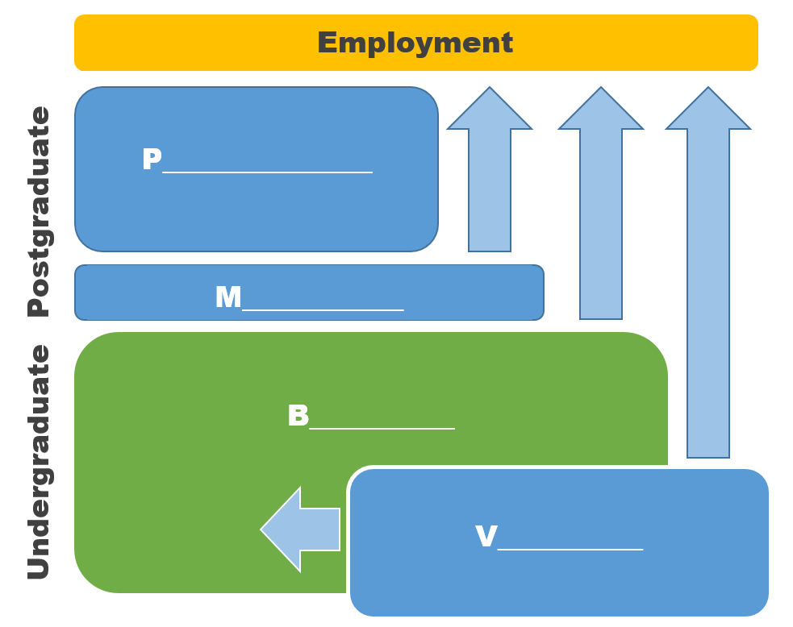

### LISTENING I

**Exercise 18**

**You are going to watch a video about Oxbridge:**

<https://www.youtube.com/watch?v=Re3tfjcZBQk>

**a. BEFORE YOU WATCH. Answer the questions.**

Have you ever heard of Oxbridge before?

What do you think are the advantages and disadvantages of studying at a collegiate university?

**b. WHILE YOU WATCH. Listen and** **fill in the gaps with the suitable words.**

1. Oxbridge is an ___________ of two distinct, but similar universities called Oxford and Cambridge.

2. One of the most defining features of both Oxford and Cambridge is that they are ___________ universities.

3. Cambridge is made up of _______ individual colleges, and Oxford is made up of _________. Some are postgraduates only.

4. Colleges do not specialize in specific subjects but some colleges ___________ in specific subjects for example Trinity College Cambridge is very well-known for _________.

5. Another thing that sets Oxford apart from other universities is that some of their classes called _________ like in Cambridge or _________ of Oxford.

**c. AFTER YOU WATCH. Answer the questions**.

1. How was Cambridge founded?

2. Do Oxford or Cambridge have central university? If not, explain their system.

3. Do all colleges offer the same courses?

4. What is special about the teaching format at Oxford?

5 Who are supervisors? Should they be from the same with your college?

6. Can you apply to both Oxford and Cambridge in the same year?

7. What is Open Application?

### VOCABULARY II

**Exercise 19**

**Match the terms with the definitions.**

|  |  |
| --- | --- |
| 1. research | 1. small group sessions where students can receive individualized instruction from a teacher or tutor. |
| 1. tuition fees | 1. money given by a university to pay for the studies of a person with great ability but little money. |
| 1. full time | 1. a course of study that allows you to work or attend classes for only some of the day or week. |
| 1. part time | 1. a place where someone lives or stays, especially when they are away from home. |
| 1. tutorials | 1. involves regular attendance of lectures and seminars on the schedule. |
| 1. scholarship | 1. money that students pay for their teaching. |
| 1. accommodation | 1. money given by the government to a person or organization for a special purpose. |
| 1. grant | 1. systematic investigation into and study of materials and sources in order to establish facts and reach new conclusions. |

**Exercise 20**

**a. Make up all possible word combinations and translate them.**

|  |  |
| --- | --- |
| 1. to provide | 1. topics |
| 1. to cover | 1. tutor |
| 1. to give | 1. information |
| 1. to meet with | 1. courses |
| 1. to discuss | 1. opportunities |
| 1. to debate | 1. hands-on experience |
| 1. to deliver | 1. costs |
| 1. to present |  |

**b. Complete the sentences with the word combinations from (a).**

1. This course _______ students _________ with C++.
2. The magazine_____________ related to radio and radio communication.
3. The Career Fair_____________ for direct communication between Yandex and the RTU MIREA students.
4. I'm going to study every day and _________ on Wednesday to prepare for Friday's test.
5. Three important ________ ______ during our meeting.
6. The_________________ to Moscow the same day.
7. In the end, all their accommodation_____________.

**c. Make your own sentences with the word combinations from (a).**

### READING II

**Exercise 21**

**Read the text and give it a title.**

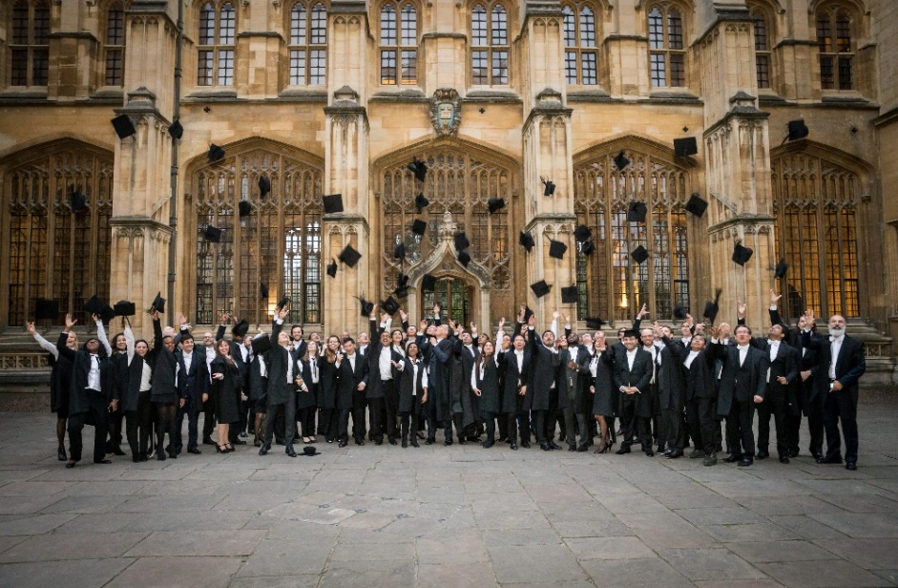Studying engineering at Oxford can be a challenging but rewarding experience. The University of Oxford provides both undergraduate and postgraduate courses in engineering, with options for full-time or part-time study.

For undergraduates, there are two main degree options: the Bachelor of Arts (BA) in Engineering Science and the Bachelor of Engineering (BEng) in Engineering Science. The BA is a three-year course that covers a broad range of topics, while the BEng is a four-year course that allows for greater specialization. Both courses give opportunities to study abroad to apply theoretical knowledge in practice.

Postgraduates have a variety of options including MSc and DPhil degrees. These programs enable students to specialize in areas such as biomedical engineering, electrical engineering, or mechanical engineering, among others.

Teaching styles at Oxford are unique and involve a combination of tutorials, lectures, seminars, and practical work. Tutorials are small group sessions where students meet with their tutor to discuss and debate topics covered in lectures and readings. Lectures are traditional form of teaching, with professors delivering information to larger groups of students. Seminars give the opportunity for students to present their own research and ideas, while practical work provides hands-on experience with engineering concepts.

Tuition fees at Oxford are higher than at many other universities, but there are grants and scholarships available to help cover costs. Students have the option of accommodations on campus or in nearby apartment complexes, according to their preference.

Studying engineering at Oxford is a rigorous experience, but one that leads to exciting career opportunities. With a focus on both theoretical knowledge and practical application, students will graduate from the university with a strong foundation in engineering principles and the skills needed to succeed in the field.

**Exercise 22**

**Answer the questions.**

1. What are the main undergraduate degree options in engineering at Oxford?
2. What is the purpose of tutorials in engineering courses at Oxford?
3. What is the teaching style like for engineering courses at Oxford?
4. Are there grants and scholarships available to help cover tuition fees for engineering courses at Oxford?
5. What career prospects can be achieved by studying engineering at Oxford?
6. How would you yourself feel about studying engineering at Oxford?

### LISTENING II

**Exercise 23**

**You are going to watch Cambridge University video about Engineering Course at**

<https://www.youtube.com/watch?v=qWijZcXRwDA>

**a. BEFORE YOU WATCH. Try to guess.**

What does engineering course at Cambridge involve? Does it differ from Oxford course?

What are the career prospects of Cambridge graduates?

**b. WHILE YOU WATCH. Listen and complete the summary of the video.**

The first years are completely general, which is one of the reasons I was attracted to it because I had no idea which field I would ___________.

You can specialise in ______, ______, materials engineering, aerothermal engineering, _______, manufacturing, ______ studies.

My favourite thing about the course is ________.

In my second year the integrated design project was very interesting, it was_______ when it actually worked out.

We have four exchange schemes whereby our students in their third year will go ______ to various parts of Europe and do a year there.

The university has a requirement that we do eight weeks ______ work.

There's also the ______ which gives you a unique opportunity to study languages within your own department.

Most of our graduates do ______, either immediately on graduating or not too long afterwards.

_______really value the Cambridge degree.

We have companies picking up our students because they're known for their ______.

**c. Watch the video for the second time and answer the questions.**

1. What is engineering?
2. When do students have to decide which branch of engineering to specialize in?
3. What branches of engineering can the students specialize in?
4. How many exchange schemes are available for students in the third year? What are they?
5. What is the most important thing to do during an engineering interview?

**d. AFTER YOU WATCH. Answer the question:**

**What are similarities and differences between studying engineering at Oxford and at Cambridge?**

**Exercise 24**

**a. Read students' comments about the teaching methods at Oxford and Cambridge.**

**b. Fill in the blanks with the following words:**

|  |
| --- |
| *support personalized problem-solving skills tutors compare*  *teamwork critical thinking* |

|  |
| --- |
| *“Tutorials are an excellent way for students to receive ________ attention and ______ in their studies. During these sessions, ______ can provide feedback on assignments, answer questions and help us develop our ________ skills. The Socrates method is often used in tutorials, which involves asking questions to encourage us to analyse and ________ different ideas. One of the main benefits of tutorials is that they offer a space for _____. This approach develops not only _________ but also helps us to learn how to articulate our thoughts more clearly”.*  *Freya, St. Catherine’s College* |

|  |
| --- |
| *presenting respond to writing feedback analytical communication skills questions* |

|  |
| --- |
| *“During a supervision, students may be asked to present their work or _______specific _____. This can be daunting at first, but for me it is an excellent opportunity to improve _________ and gain confidence in ______ ideas. Tutors will offer constructive ______ and suggestions for improvement, helping students to refine our ______ and _______skills.”*  *Alex, King’s College* |

### SPEAKING

**Exercise 25**

**Work in groups. Discuss the advantages and disadvantages of tutorials and supervisions. What teaching methods are used at your university? Do you have tutorials? Do you consider such methods useful? Why? Why not?**

**Use the following:** *student-centred; co-operation; teamwork; highly effective; individual work; critical thinking; problem solving; communication skills.*

### WRITING

**Exercise 26**

**Writing Email to Your Professor.**

1. **Read email sample.**

|  |
| --- |
| **drradley@unoxf.com**  **Subject:** *Request for notes* |
| *Dear Dr. Radley,*  *This is Tom White from your math class. I am sorry for missing class last Monday, but I had a family emergency that I needed to attend to. I regret missing your lecture and I hope that you give me notes for the material I missed. I would appreciate your help.*  *Thank you,*  *Tom White* |

**b. Study the rules of email writing:**

**1. Use your academic email address.**

Most universities provide students with an academic email address. If your school has provided you with one, use it. Using a personal email like skylarx3george@aol.com increases the chances of your email ending up in the spam folder or getting skipped.

**2. Write a clear and concise subject line.**

It’s always a good idea to give your professor a preview of what the email is about, and that’s what the subject line is for. Make sure the subject line is clear, concise, and informative.

**3. Use a formal salutation.**

Use Dear or Hello when starting an email to your professor.

**4. Introduce yourself.**

Professors can have numerous students. You can’t expect them to know who you are solely by your email. After the formal salutation, write your full name and the course you’re taking.

**5. Write a brief message about why you’re emailing.**

Professors are extremely busy people. Don’t ramble in your email. Instead, get straight to the point. Write your email as briefly as possible. Additionally, make sure to use the appropriate tone and language.

**6. End the email with a formal closing.**

Once you have asked your question or made your requests, end the email with a formal closing like Thank you, Best, or Sincerely. Then write your name.

**7. Check for spelling and grammar errors.**

Arguably the most important part of writing an email to your professor is checking for spelling and grammar mistakes. A message riddled with errors can make it seem as if you’re not taking the time to write a professional and proper email.

**c. Write an email to your professor saying that you would like to retake a test or exam.**

## Theme 2.2. Higher Education in the USA

### LEAD IN

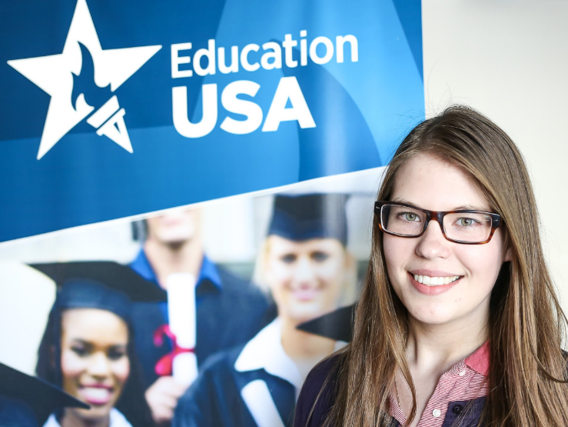

**Work in pairs and explain how you understand this quotation:**

*Education is the most powerful weapon which you can use to change the world.*

*- Nelson Mandela*

*KEY WORDS AND WORD COMBINATIONS*

|  |  |  |
| --- | --- | --- |
| dedication (n) | [dedɪˈkeɪʃn] | стремление, сосредоточенность, усердие |
| extensively (adv.) | [ɪksˈtensɪvlɪ] | много, активно, в больших количествах |
| to achieve (v) | [əˈʧiːv] | достигать, добиваться, выполнять |
| major (n)  to major (v) | [ˈmeɪʤə] | ведущее направление подготовки, специальность, основной предмет:  специализироваться в изучении какого-либо предмета |
| credit hours (n+n) | [ˈkredɪt ˈaʊəz] | единица учебной нагрузки, определённое количество которых необходимо набрать для получения зачёта |
| to evolve (v) | [ɪˈvɒlv] | развиваться, изменяться |
| to aim (v) | [eɪm] | стремиться, ставить целью |
| grades (n) | [greɪds] | баллы, оценки |
| eligibility (n) | [elɪʤəˈbɪlɪtɪ] | соответствие установленным требованиям, критериям |
| to specialise in (v) | [ˈspeʃəlaɪz ɪn] | специализироваться на чем-то |
| to determine (v) | [dɪˈtɜːmɪn] | определять, обуславливать |
| compulsory (adj) | [kəmˈpʌlsərɪ] | обязательный, общеобразовательный |
| elective (adj) | [ɪˈlektɪv] | факультативный, элективный, по выбору |
| to tailor (v) | [ˈteɪlə] | приспосабливать, проектировать, специально разрабатывать |
| to fulfil (v) | [fʊlˈfɪl] | выполнять, соответствовать |
| requirements (n) | [rɪˈkwaɪəmənt] | требования |

### PRONUNCIATION PRACTICE

**Exercise 1**

**Practice saying the key words and word combinations.**

**Exercise 2**

**Give the correct word for each phonetic description.**

|  |  |
| --- | --- |
| [əˈsəʊʃ(ɪ)ət, əˈsəʊsɪət] |  |
| [kəmˈpʌlsərɪ] |  |
| [rɪˈsɜːʧ] |  |
| [ɪˈlektɪv] |  |
| [əˈʧiːv] |  |
| [sɪgˈnɪfɪkənt] |  |

### VOCABULARY I

**Exercise 3**

**Match the word combinations with their Russian equivalents.**

|  |  |
| --- | --- |
| 1. intended career | 1. старшие классы средней школы |
| 1. job market | 1. вуз |
| 1. high school | 1. будущая карьера |
| 1. higher school | 1. окружной двухгодичный колледж, муниципальный колледж |
| 1. community college | 1. степень (диплом) младшего специалиста |
| 1. associate degree | 1. магистратура |
| 1. graduate school | 1. рынок труда |

**Exercise 4**

**Match the synonyms.**

|  |  |
| --- | --- |
| 1. to evolve | 1. to achieve |
| 1. to get | 1. to begin |
| 1. to fulfil | 1. to demand |
| 1. to tailor | 1. to develop |
| 1. to start | 1. to modify |
| 1. to require | 1. to obtain |

**Exercise 5**

**Match the antonyms.**

|  |  |
| --- | --- |
| 1. advanced | 1. lower |
| 1. higher | 1. optional |
| 1. pass | 1. obligatory |
| 1. compulsory | 1. basic |
| 1. elective | 1. insignificant |
| 1. significant | 1. narrow |
| 1. extensive | 1. fail |

**Exercise 6**

**a. Make word combinations.**

|  |  |
| --- | --- |
| 1. to meet | 1. exams |
| 1. to pass | 1. a particular field |
| 1. to fulfil | 1. critical thinking skills |
| 1. to tailor | 1. goals |
| 1. to specialize in | 1. requirements |
| 1. to practice | 1. a research |
| 1. to conduct | 1. demands |
| 1. to achieve | 1. education |

**b. Complete the sentences using word combinations from (a).**

1. The Master's program in Computer Science offers you a vast number of opportunities to ___________.
2. Students learn to work together and _______ conflict resolution and______.
3. The research ______ on the basis of Harvard University.
4. Kate _____ her _____ to study at a US university.
5. The full-time programme is designed ____ the growing _____ for graduates with analytical skills.
6. This programme allows students to ________ of their national or state educational systems.
7. He ______ his final _______ and got into college without difficulty.
8. A large number of elective courses allows students ____ their ___ to meet personal and professional goals.

### GRAMMAR

**Study grammar rules on the use of** **the Perfect and Perfect Progressive (Continuous) (see GRAMMAR REFERENCE p. 97)**

**Exercise 7**

**Put the words in brackets in the correct form.**

1. She _____ the university of her dreams this year. (to enter)
2. He _______ diligently all the semester, preparing for his final exams. (to study)
3. By the time she entered the university, she ___ already ____ for a course in medicine and gained significant practical experience. (to apply)
4. He plans to enter the university next year and believes that by the time he graduates, he ______ a degree that opens up opportunities for employment. (to obtain)
5. They ____ diligently _____on their projects, pursuing their Master's degrees. (to work)
6. By the time he retired, he _____ at the school for over 40 years. (to teach)
7. In five years, he ____ at the university for twenty years. (to lecture)

**Exercise 8**

**Make sentences from the given words in 6 tenses (Present, Past and Future Perfect and Present, Past, and Future Perfect Progressive):**

*do, send, make, study, graduate, award, prepare, complete, gain***.**

***Model:***

|  |  |
| --- | --- |
| Amy has sent lots of emails this morning.  Amy has not sent lots of emails this morning.  Has Amy sent lots of emails this morning? | He has been studying mathematics for six years only.  He has not been studying mathematics.  Has he been studying mathematics for six years? |
| The student had done everything he could.  The student had not done everything he could.  Had the student done everything he could? | He had been doing everything the doctors told him to.  He had not been doing everything the doctors told him to.  Had he been doing everything the doctors told him to? |
| Tom will have graduated from the university in two years.  Tom will not have graduated from the university in two years.  When will Tom have graduated from the university? | I will have been studying for two hours by the time you arrive.  I will not have been studying for two hours by the time you arrive  How long will I have been studying by the time you arrive? |

**Exercise 9**

**a. Translate sentences from Russian into English using Perfect.**

1. Анна только что закончила первый год обучения на очном отделении.
2. В этом году университет выдал дипломы тысячам выпускников, завершившим обучение на бакалавриате.
3. Перед тем как перейти на курс профессиональной переподготовки, Диана прошла курс, совмещающий теорию и практику и приобрела ценный опыт.
4. В течение 3 месяцев Том работает над своим исследовательским проектом.
5. К концу следующего года Денис завершит обучение в магистратуре.
6. Юлия путешествовала по миру в течение года, прежде чем поселиться в своем родном городе.

**b. There are sentences with Perfect Tenses in the text “*The system of higher education in the United States”* (Ex.10). Find them and comment on their use.**

### READING I

**Exercise 10**

**Read and translate the text.**

*THE SYSTEM OF HIGHER EDUCATION IN*

*THE UNITED STATES*

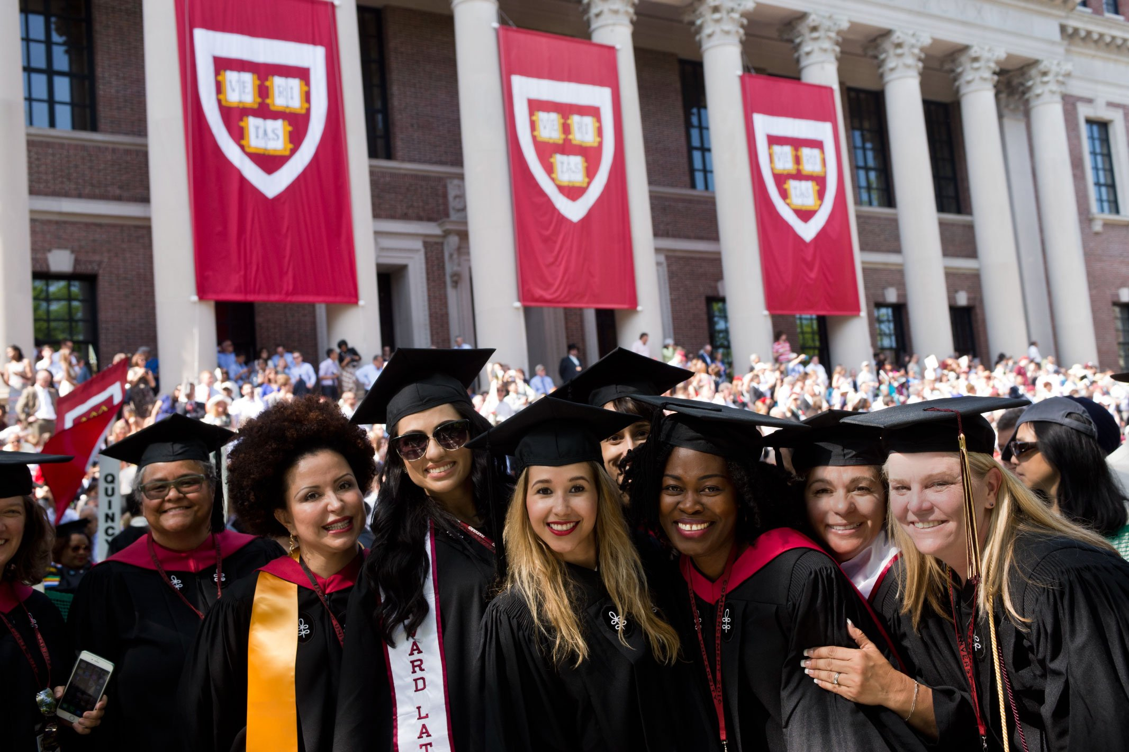 The system of higher education in the United States has evolved significantly over the years. It has always aimed to prepare students for their intended careers, but the structure and offerings have changed to meet the demands of a dynamic job market.

Many students pursue higher education after completing their high school diploma, aiming to get a bachelor's degree or an advanced degree such as a Master's or PhD.

To gain a degree in the USA, students must pass exams and fulfill the requirements of their chosen program at a higher educational institution. These institutions are universities, community colleges, or other specialized schools. In some cases, certain courses are compulsory, while others are elective, allowing students to tailor their education to their interests and goals.

Community colleges are a popular option for students who want to start their higher education journey with lower costs or who are unsure of their major. They offer 2 year courses and programs that can lead to a certificate, associate degree, or transfer to a university to complete a bachelor's degree. As of January 2023, there were 935 public community colleges registered with the AACC* in the United States.

Universities are the most common choice for pursuing a bachelor's degree (BA, BSc, and BBA). There are more than 1000 universities in the USA. Students typically spend four years studying a variety of subjects and earning grades that will determine their eligibility for graduate school or a career. Many universities also offer master's courses (MSc degree) and PhD programs for those looking to specialize in a particular field.

Obtaining an advanced degree opens doors to more specialized careers and higher-paying jobs. However, it requires a significant amount of time and dedication to complete. Students practice critical thinking skills, conduct research, and write extensively.

Higher education is an important step towards achieving one's career goals in the USA. Whether pursuing a bachelor's degree, an advanced degree, or attending community college, students try to work hard, pass exams, and complete their degree requirements.

**Notes\***

*AACC (The American Association of Community Colleges) – Американская ассоциация муниципальных колледжей*

**Exercise 11**

**a) What do these numbers refer to:**

2023, 2, 935, 1000, 4**?**

**b) What do these abbreviations stand for:**

USA; AACC, MSc, PhD, BA, BSc, BBA**?**

**Exercise 12**

**Find the words in the text that mean:**

1. required by law or a rule, obligatory;
2. the highest degree awarded by a graduate school or department, usually after several years of original research culminating in a dissertation;
3. an undergraduate academic degree awarded by colleges and universities upon completion of a course of study usually lasting three to five years;
4. optional or chosen according to individual preference;
5. two-year institutions of higher education that offer courses leading to an associate degree or certificate;
6. a postgraduate academic degree such as a master's or doctoral degree;
7. institution of higher education that typically consists of several colleges and graduate schools and are authorized to confer degrees in various fields.

**Exercise 13**

**a. Decide if the statements below are true or false.**

1. The system of higher education in the United States has remained unchanged over the years.
2. Students can only pursue a bachelor's degree in the USA.
3. Students must pass exams and fulfill program requirements to gain a degree in the USA.
4. Community colleges are not a popular option for students.
5. Community colleges offer programs that can lead to a bachelor’s degree.
6. There are more than 1000 universities in the USA.
7. Students typically spend two years studying at community colleges.
8. Obtaining an advanced degree requires less time and dedication than obtaining a bachelor's degree.
9. Students at universities only study subjects related to their major.
10. Higher education is not important for achieving career goals.

**b. Make up your own true or false statements.**

**Exercise 14**

**a. Answer the questions:**

1. What are the requirements for completing a degree in the USA?
2. What types of institutions offer higher education programs?
3. What is the difference between compulsory and elective courses in higher education programs?
4. Why are community colleges popular among students, and what types of degrees do they offer?
5. What is the most common choice for pursuing a bachelor's degree in the USA, and how long does it typically take to complete?
6. What opportunities are available to students who pursue advanced degrees like Master's or PhD programs?
7. How can obtaining an advanced degree benefit one's career prospects?
8. What skills do students practice when pursuing an advanced degree?

**b. Retell the text in your own words. Say as much as you can recall for someone who has not read the text. Don’t look back at the text. Use the questions as a plan for retelling the text.**

**Exercise 15**

*British English and American English (Vocabulary on Education)*

|  |  |
| --- | --- |
| **UK** | **USA** |
| university | college / school |
| public school — частная школа | public school — государственная школа |
| tuition — обучение | tuition — плата за обучение |
| to read / to do a subject | to major in a subject |
| to revise for an exam | to review for an exam |
| practice/to practise | practice/to practice |
| marks | grades |
| first-year student  second-year student  third-year student | freshman (frosh)  sophomore  junior  senior |
| Staff:  Professor  Reader  Senior Lecturer  Lecturer | Faculty:  Full Professor  Associate Professor  Assistant Professor |
| letter of reference | letter of recommendation |

**Exercise 16**

**Decide if these statements are about the UK or the USA:**

1. Alex read History at the university.
2. He majored in computer science at college.
3. Tom was awarded high marks for his project.
4. Examinations are graded honors, pass, low-pass or fail.
5. Students attending full-time programs receive free tuition at state institutions.
6. This scholarship not only covers tuition fees but also covers living expenses.
7. Each year has a name: freshman, sophomore, junior, senior.
8. She is a third year student.
9. Applicants were asked to provide letters of reference.
10. Our school is led by a diverse and dedicated group of faculty and scholars.

### LISTENING I

**Exercise 17**

**You are going to watch a video about the U.S. higher education system at**

<https://www.youtube.com/watch?v=QcCJ8nZop-A>

1. **BEFORE YOU WATCH. Answer the questions.**
2. How can you characterize the American higher education system?
3. What are the distinctive features of the higher education system in the U.S.?

**b. WHILE YOU WATCH. Listen and fill in the gaps with the suitable words.**

The U.S. higher education system is a bit like the American character. It celebrates ___, ________, ______, and _________.

The U.S. higher education system also has its own names for each year of an ______ degree, which you may or may not be familiar with. For example, the first year of a degree is known as the ______ year, the second as the _____ year, the third as the _____ year, and the final as the ______ year. A typical American student will complete 12 years of education before progressing to college ______ a bachelor's degree, which takes _____ years to complete.

Some students continue to graduate school to study for a ______, which takes an additional ___ to _____ years. U.S. undergraduate degrees usually require four years of ______ study.

The academic year runs for ___ months, with ____ semesters per year. Each semester, you'll study four or five courses, and each course you study will earn ________. There are usually three to four _____ per course, and you'll be expected to complete 120 to 130 credit hours in order to complete an undergraduate degree.

**c. AFTER YOU WATCH. Answer the questions**.

1. What are the names of each year of an undergraduate degree in the US higher education system?
2. How many years does it take to complete a bachelor's degree in the US?
3. What is the typical educational background of an American student before pursuing a bachelor's degree?
4. What is the duration of an academic year in the US higher education system?
5. How many courses do students usually study per semester in the US higher education system?
6. How many credits are usually earned per course in the US higher education system?
7. How many credit hours are required to complete an undergraduate degree in the US?
8. What is the duration of a master's degree program in the US?
9. What are the values celebrated by the US higher education system?

### GRAMMAR REVISION

Active vs Passive

**Exercise 18**

**Choose the correct form of the verb**.

1. Stanford University Library *houses/is housed* a vast collection of books and digital resources.
2. The digital catalog *is updated/updated* by Stanford University Library to enhance accessibility.
3. The library's extensive archives *utilize/are utilized* for historical studies by researchers.
4. The library staff *was organized/organizes* regular events to promote literacy and community engagement.
5. The library's physical spaces *are designed/designed* to foster learning, creativity, and collaboration.
6. The library continually *invests/was invested* in digital archives, specialized databases, and advanced research tools.
7. Stanford University Library *offers/is offered* a welcoming and enriching environment that celebrates the pursuit of knowledge.

### VOCABULARY II

**Exercise 19**

**a.Match the word combinations with their Russian equivalents.**

|  |  |
| --- | --- |
| 1. to work your socks off | 1. нестандартный подход |
| 1. stellar reputation | 1. обеспечение высоких стандартов обучения |
| 1. academic excellence | 1. выдающиеся выпускники |
| 1. rigorous demands | 1. много работать |
| 1. to drink from a firehose | 1. студенческий состав |
| 1. accomplished alumni | 1. имеющий хорошую успеваемость |
| 1. student body | 1. безупречная репутация |
| 1. academically proficient | 1. любознательность |
| 1. intellectual curiosity | 1. жёсткие требования |
| 1. unconventional approach | 1. быть перегруженным информацией |

1. **Make your own sentences with the word combinations from (a).**

### READING II

**Exercise 20**

**Read and translate the text, find in the text sentences with Perfect.**

*WHAT'S IT LIKE TO STUDY AT MIT?*

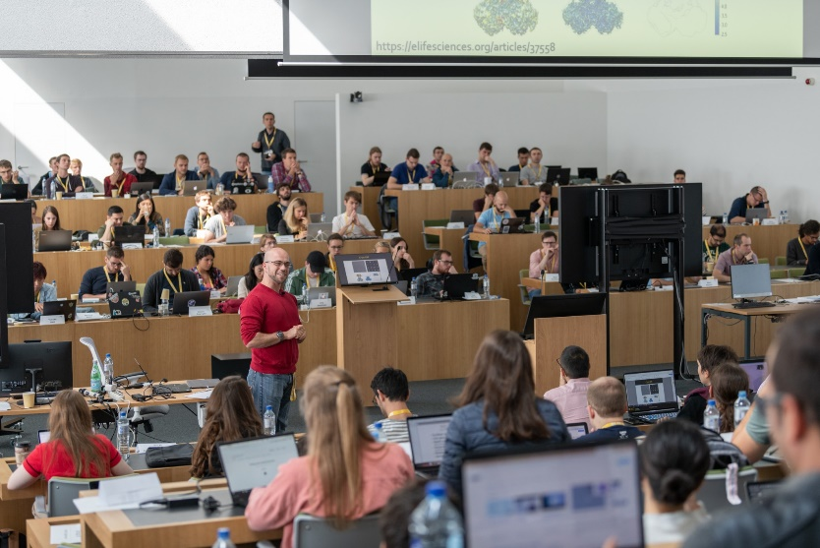Studying at the Massachusetts Institute of Technology (MIT) is a dream come true for many aspiring minds. Named the number one university in the world in the latest QS* league table, MIT has earned a stellar reputation not only for its academic excellence but also for its rigorous demands. As the saying goes, "If you are considering studying at the best university in the world, you'd better be prepared to work your socks off."

The pace of learning at MIT has often been likened to "drinking from a firehose," and this reputation is well deserved.

The workload is intense. Amy Guyomard, a third-year maths major, shares her experience, mentioning that she had already submitted two problem sets and a writing assignment just four days into the semester. Her to-do list includes two more problem sets and a 20-minute presentation, not to mention reading "All The President's Men" by week's end.

MIT is known not only for its challenging workload but also for producing some of the brightest minds in the world. The university boasts a long list of accomplished alumni, including the fictional Tony Stark (Iron Man) and the character from "Good Will Hunting," played by Matt Damon.

Admission to MIT is highly competitive. The institute seeks exceptional students who are not only academically proficient but also exhibit initiative and intellectual curiosity.

MIT's student body is diverse, encompassing a wide range of personalities and interests. This diversity reflects the institute's philosophy that "MIT is as hard as you want to make it." While the journey may be challenging, MIT ensures that students come out better than they went in.

One of the remarkable aspects of MIT is its focus on fostering personal growth and individual learning styles. As Michael Plasmeier, a management and computer science student, notes, "Information is not spoon-fed*; you need to find your own personal style of learning." This emphasis on self-discovery and adaptability prepares students for the real world, where innovation and problem-solving often require unconventional approaches.

*(retrieved from: https://www.theguardian.com/education/)*

***Notes*:***

*QS – Quality Standards;*

*to be spoon-fed – to be given too much help or information.*

**Exercise 21**

**Answer the questions, use additional information from the Internet.**

1. What is MIT?
2. Why is MIT considered one of the best universities in the world?
3. How would you describe the pace of learning at MIT, and what kind of workload do students face?
4. Who are some famous alumni of MIT?
5. What are they famous for?
6. Is admission to MIT competitive, and what qualities does the institute look for in applicants?
7. What kind of student body does MIT have?
8. What is MIT's focus?
9. How does MIT prepare its students for the real life?

### LISTENING II

**Exercise 22**

**a. BEFORE YOU WATCH. You are going to watch a video “5 Signs you are an engineering student”. Look through the sentences and try to guess the missing words:**

1. You soon learn the true meaning of _____, pressure and strain.
2. You still think _____ is the best kids toy ever.
3. You're always trying to ____ things.
4. Your family and friends like to make use of your _____ skills around the house.
5. By the time your art student friends get out of bed, you've already been to two ____ and a ___ session.
6. **WHILE YOU WATCH. Watch the video at** [**https://www.youtube.com/watch?v=tNqyLJNie-s**](https://www.youtube.com/watch?v=tNqyLJNie-s) **and check your predictions. What is the meaning of *stress, pressure and strain* in this video?**

**c. AFTER YOU WATCH. Answer the questions.**

1. What are some of the things that engineering students learn about?
2. Do you agree that Lego is the best kids toy ever? Why or why not?
3. How do your family and friends make use of your DIY skills?
4. Do you think engineering is a difficult major? Why or why not?
5. What are the benefits of studying engineering?
6. How do you balance your academic workload with your personal life?
7. What are some of the skills that you have developed as an engineering student?
8. What advice would you give to someone who is considering studying engineering?
9. What are some common stereotypes about engineering students?

### SPEAKING

**Exercise 23**

**a. Imagine that your dream is to enter MIT and you are talking to one of the MIT students. Prepare a list of questions. Some of them are done for you.**

Student A: Hey, I heard you're studying computer science here at MIT. How's your experience been so far?

Student B: It's been amazing! The curriculum is rigorous, but I'm loving it. How about you?

Student A: __________________. Can you tell me ________?

Student B: Sure, MIT offers a wide range of subjects within the computer science department. There are mandatory curriculum courses that everyone takes, which provide a solid foundation. Then, there are optional subjects that allow you to specialize in areas you're interested in.

Student A: That sounds flexible. ________________?

Student B: Most lectures are full-time, but MIT does offer some part-time and distance courses to accommodate different schedules and preferences. It really depends on your needs.

Student A: That's good to know. What about ________? Have you applied for any __________?

Student B: Yes, MIT offers various scholarships and financial aid options for eligible students. It's a competitive process, but it's worth applying if you need assistance.

Student A: I see. And what about assessments? _________tests and exams?

Student B: We do have tests and exams, especially in the core subjects. But there are also assignments, essays, and projects that contribute to our grades. It's a balanced mix of assessment methods.

Student A: Sounds challenging but fair. _______________?

Student B: The sandwich course has been great for gaining practical experience. It involves apprenticeships, which are valuable for building your resume and network.

Student A: That's awesome. I'm really considering MIT now. Thanks for sharing your insights!

Student B: You're welcome! Feel free to ask if you have any more questions. MIT is a fantastic place to study computer science, and I'm sure you'll enjoy it if you decide to join.

**b. Practice the conversation in pairs.**

### WRITING

**Exercise 24**

**Writing a Motivation Letter for University.**

1. **Read Motivation Letter sample.**

|  |
| --- |
| **Motivation letter**  Degree: Master  Major: Engineering  University: Harvard University, USA  Author: Peter Atkins, USA  Dear sir /Madam,  First of all, let me introduce myself, I am Peter Atkins and recently I have been working in Americatelecom as a Network Engineer. I have attended my B.Sc degree in Computer Science and Engineering (Software Engineering Stream) from Princeton University. The undergraduate curriculum in Computer Science and Engineering at institute of technology, Princeton University introduces me to a wide variety of engineering subjects.  Various courses like Artificial Intelligence, Programming Languages, Electronics, Software Engineering, System Programming, Micro Processor, Interfacing & Assembly, Algorithm Analysis and Design, Digital Signal Processing, Network and System Security, Computer graphics and multimedia, Computer Simulation and Modelling provided me with a strong footing in the theoretical concept of Computer Science and Engineering.  While offering both depth and breadth across this field, these courses put into perspective the importance and relevance of Computer Science and Engineering and the application of its fundamentals to the problems faced by the real world. So, I can realize that learning and developing my knowledge of Computer Science, I will have a great contribution to the society since our country begins to transfer manual system to computerize. I am much eager to adopt and know new technologies.  I am really enthusiastic to attend a Master of Computer Science in order to understand different Computer Science Concepts, because every industry needs the concept of Computer Science. Good reputation of high-quality education standards, an extremely distinguished faculty members and research facilities are the factors which have motivated me to choose for my M.Sc. studies at Harvard University. Moreover, I feel I am responsible for making a big move in this field and this scholarship will give me a big chance to be one day someone who is remembered for his innovations.  I think it is our duty as people sharing life in this world to make our future better because the future is not only ours. Our grandchildren should be proud of us one day when they look back and find how hard we worked to make the world a better place. I believe my qualification and your needs would be an excellent fit. I will be happy to provide any further information or documents if required. I look forward to your positive response.  Thank you for your time and consideration.  Yours faithfully. |

**b. Study the rules of Motivation Letter writing:**

Writing a compelling motivation letter for university admission is crucial to making a positive impression on the admissions committee. Here are some important rules and guidelines to follow when crafting your motivation letter:

1. **Follow the University's Guidelines:** Before you start writing, carefully review the university's admission requirements and any specific guidelines provided for the motivation letter. Follow any formatting, length, or content instructions provided.
2. **Address it Correctly:** Use the appropriate salutation and address the letter to the correct department or individual, if possible. If you don't have a specific contact, use a general salutation such as "Dear Admissions Committee".
3. **Professional Tone:** Maintain a professional and formal tone throughout the letter. It should be well-structured and free from slang or overly casual language.
4. **Introduction:** Begin with a clear and engaging introduction that states your purpose for writing the letter. Express your enthusiasm for the program and university you're applying to.
5. **Highlight Your Qualifications:** Explain why you are a suitable candidate for the program. Highlight your academic achievements, relevant experiences, skills, and any other qualifications that are pertinent to your application.
6. **Show Passion:** Convey your genuine passion for the field of study and your eagerness to learn and contribute to the academic community. Explain what motivates you and how the program aligns with your goals.
7. **Provide Specific Examples:** Use concrete examples from your past experiences to illustrate your qualifications and commitment. Describe relevant projects, internships, or research you've been involved in.
8. **Address Weaknesses:** If you have any weaknesses in your application (e.g., low grades in certain courses), briefly address them but focus on how you have learned and grown from those experiences.
9. **Explain Why This University:** Clearly articulate why you are interested in this specific university and program. Mention faculty members, research projects, or unique opportunities that attracted you to the institution.
10. **Tailor the Letter:** Customize your motivation letter for each university and program you apply to. Avoid using a generic template that could apply to any institution.
11. **Be Concise:** Adhere to the recommended word count or page limit. Keep the letter concise and focused on the most relevant information.
12. **Proofread and Edit:** Carefully proofread your letter for grammar and spelling errors. You may even consider seeking feedback from professors, mentors, or peers to improve its quality.
13. **Honesty and Authenticity:** Be honest and authentic in your writing. Avoid exaggerating or making false claims about your qualifications or experiences.
14. **Closing:** End your letter with a strong conclusion that reiterates your enthusiasm for the program and expresses your hope for a positive outcome. Use a formal closing, such as "Sincerely" or "Yours faithfully."
15. **Include Relevant Enclosures:** If the university requests additional documents (e.g., transcripts, CV, letters of recommendation), make sure to include them with your motivation letter.

Remember that a well-written motivation letter can be a crucial component of your university application. It provides the admissions committee with insight into your personality, motivations, and qualifications, helping them make informed decisions about your admission. Tailor each letter to the specific institution and program, and take the time to make it as compelling and authentic as possible.

**c. Write a motivation letter to the university you would like to enter.**

# SUPPLEMENTARY EXERCISES

**Exercise 1.**

**a. Choose the correct form of the verb (Active or Passive):**

OXFORD IN NUMBERS

1. The student body *numbers/is numbered* 24 000 people with almost 40% coming from outside the UK.
2. Oxford *boasts/ is boasted* 47 libraries in total, including the largest university press in the world.
3. Oxford's famous Bodleian Library is *held /holds* over 12 million items, including a Gutenberg Bible and Shakespeare’s First Folio.
4. Over 11,000 people *employ/are employed* by the University of Oxford, making it the largest employer in the city.
5. Oxford's Engineering Science program *is attracted /attracts* top students from around the world, with 43% of undergraduates coming from outside the UK.
6. Undergraduate students *make/are made* up 53% of the total number.
7. 9 million *spends/is spent* every year on financial support of for under- graduates.
8. Oxford *offers/is offered* more than 300 different graduate programmes.
9. Students *teach/are taught* by 1 800 lecturers.
10. The academic staff *includes/is included* citizens of 100 countries.

**b. Complete the sentences with the correct form of the verbs in brackets (Active or Passive):**

CAMBRIDGE IN NUMBERS

1. Cambridge University ___ (*to found*) in 1209.
2. It _______ (*to produce*) 120 Nobel Laureates.
3. Cambridge____ (*to have*) over 31 colleges and 100 academic departments.
4. Undergraduate degrees____ (*to obtain*) at 29 colleges.
5. 8 million volumes_______ (*to contain*) in the University library.
6. The Fitzwilliam Museum ____ (to *house*) over half a million works of art and artifacts.
7. 3 years of accommodation_____ (*to guarantee*) for Cambridge students.
8. Cambridge University_____ (*to employ*) more than 2,500 academic staff.
9. The annual turnover of Cambridge's tech industry ____ (*to estimate*) at over £4.8 billion.
10. Over 13,300 international students____ (*to study*) at Cambridge.

**Exercise 2.**

**Internet Activity**

**Work in pairs. Student A looks at the official website of Oxford University Department of Engineering Science:** [**https://eng.ox.ac.uk/**](https://eng.ox.ac.uk/)

**Student B looks at the official website of Cambridge University Department of Engineering:** [**http://www.eng.cam.ac.uk/**](http://www.eng.cam.ac.uk/)

**Find answers to the following questions:**

1. When was the Department of Engineering founded?
2. What degrees does the faculty offer?
3. What courses can students take?
4. What skills can the students learn?
5. Who does the academic staff include?
6. What students’ societies are there?
7. Where can students live?
8. What sports can they do?

**Exercise 3.**

**Complete the text with the correct forms of the verbs.**

Studying engineering at Harvard is a dream for many aspiring engineers, and for good reason. This prestigious institution (to attract) some of the brightest minds in the field, and its rich history stretches back over a century.

Harvard's School of Engineering and Applied Sciences (SEAS) (to be) at the forefront of technological advancements. Over the years, its faculty and alumni (to make) significant contributions to various engineering disciplines, including the development of the first computer and the creation of artificial organs.

Harvard (to emphasize) an interdisciplinary approach to engineering education. Students (to encourage) to collaborate across departments and fields, fostering innovation and creative problem solving. This approach (to lead) groundbreaking research in areas such as bioengineering, robotics, and environmental science.

Harvard's engineering faculty (to include) Nobel laureates and leading experts in their respective fields. Their commitment to teaching and research (to inspire) countless students to pursue ambitious projects and contribute to the advancement of science and technology.

**Exercise 4.**

**Internet Activity**

**Work in pairs. Student A looks at the official website of Harvard University School of Engineering:** <https://seas.harvard.edu/>

**Student B looks at the official website of Princeton University Department of Engineering:** <https://engineering.princeton.edu>

**Find answers to the following questions:**

1. When was the Department/School of Engineering founded?
2. What degrees does the university offer?
3. What courses can students take?
4. What skills can the students learn?
5. Who does the academic staff include?
6. What can you say about social life of the students?
7. Where can students live?
8. What sports can they do?

# GRAMMAR REFERENCE

### THE VERB “TO BE”

|  |  |  |  |
| --- | --- | --- | --- |
|  | **Present Simple** | **Past Simple** | **Future Simple** |
| **Positive** | **I am**  **He / she / it is We / you / they are** | **I / he / she / it**  **was**  **We / they / you**  **were** | **I / he / she / it / we / they / you will be** |
| **Negative** | **I am not**  **He / she / it is not We / you / they are not** | **I / he / she / it**  **was not**  **We / they / you**  **were not** | **I / he / she / it / we / they / you will not be** |
| **Question** | **Am I?**  **Is he / she / it? Are we / you / they?** | **Was I / he / she / it?**  **Were we / you/ they?** | **Will I / he / she / it / we / they / you be?** |

**For more grammar practice visit the Internet site and do exercises online.**

**Verb to be:** [**https://www.englisch-hilfen.de/en/exercises/tenses/be.htm**](https://www.englisch-hilfen.de/en/exercises/tenses/be.htm)

### VERB TENSES – ACTIVE VOICE

|  |  |  |  |
| --- | --- | --- | --- |
|  | **Present Simple** | **Past Simple** | **Future Simple** |
| **Positive** | I / you / we / they  live in Moscow.  He / she / it lives  in Moscow.  *never, sometimes, often, usually, always* | I / he / she / it / we / you / they moved / went to Vladivostok in 2021. *ago, last night* (*Sunday, week, year, month*)*, yesterday* (*morning, evening, afternoon*) | I / he / she / it / we / you / they will study at Moscow State University. |
| **Negative** | I / you / we / they do not (=don’t) live in Moscow.  He / she / it does not (=doesn’t) live in Moscow. | I / he / she / it / we / you / they did not (=didn’t) move / go to Vladivostok in 2021. | I / he / she / it / we / you / they will not (=won’t) study at Moscow State University. |
| **Question** | Do I / you / we / they live in Moscow? Yes, I do. No, I don’t.  Does he / she / it live in Moscow? Yes, he does. No, he doesn’t.  Where do I / you / we / they live?  Where does he / she / it live? | Did I / he / she / it / we / you / they move / go to Vladivostok in 2021?  Yes, I did. No, I did not (=didn’t).  Where did I / he / she / it / we /  you / they move / go in 2021? | Will I / he / she / it / we / you / they study at Moscow State University? Yes,  I will. No, I will not (=won’t). Where will I / he / she / it / we /you / they study? |

**Study the forms of irregular verbs:**

[**https://lingbase.com/ru/english/grammar/complete-list-of-irregular-verbs**](https://lingbase.com/ru/english/grammar/complete-list-of-irregular-verbs)

**For more grammar practice visit the Internet sites and do exercises online.**

**Present Simple:**

[**https://www.perfect-english-grammar.com/present-simple-exercise-7.html**](https://www.perfect-english-grammar.com/present-simple-exercise-7.html)

**Past Simple:**

[**https://www.perfect-english-grammar.com/past-simple-exercise-8.html**](https://www.perfect-english-grammar.com/past-simple-exercise-8.html)

**Future Simple:**

[**https://www.perfect-english-grammar.com/simple-future-exercise-1.html**](https://www.perfect-english-grammar.com/simple-future-exercise-1.html)

### THE VERB “TO HAVE”

|  |  |  |  |
| --- | --- | --- | --- |
| **Positive** | **Negative** | **Yes/**  **No-Questions** | **Wh-Questions** |
| I / we / you / they have  He / she / it  has | I / we / you / they don’t have  He / she / it  doesn’t have | Do I / we / you / they have  Does he / she / it have | What do I /  we / you / they  have?  What does he / she / it have? |

**For more grammar practice visit the site**

[**https://www.english-room.com/grammar/havehas_01.htm**](https://www.english-room.com/grammar/havehas_01.htm)

**and do exercises online*.***

### THE VERB + -ING FORM

|  |  |  |
| --- | --- | --- |
|  | **Verbs** | **Examples** |
| Likes and dislikes | like  love  enjoy  prefer  do (not) mind hate  dislike | Do you like watching movies?  I don’t mind getting up early. |
| sports and other activities | go swimming,  go skating,  go horseriding, go running,  go shopping | How often do you go shopping?  Next time let's go skating outdoors. |

### PROGRESSIVE (CONTINUOUS) ACTIVE

|  |  |  |
| --- | --- | --- |
| **be + -ing Verb** | | |
| **Present** | **Past** | **Future** |
| I am studying engineering.  She/He is studying engineering.  They/you/we are studying engineering. | I was studying engineering  He/she was studying engineering.  They/you/we were studying engineering. | I will be studying engineering.  He/she will be studying engineering.  They/we/you will be studying engneering. |
| I am not studying engineering.  She/He is not studying engineering.  They/you/we are not studying engineering. | I wasn’t studying engineering.  She/He was not studying engineering.  They/you/we were not studying engineering. | I will not (won’t) be studying engineering.  He/she will not (won’t) be studying engineering.  They/we/you will not (won’t) be studying engineering. |
| Is he/she studying engineering?  Are they/we/you studying engineering?  What is she/he studying?  What are they studying? | Was he/she studying engineering?  Were they/we/you studying engineering?  What was she/he studying?  What were they studying? | Will he/she/you/we/they be studying engineering?  What will he/she/we/you/they be studying? |

**State Verbs**

Some verbs are NOT normally used in the **Present Progressive**: like, hate, want, need, prefer, know, realise, understand, recognise, believe, suppose, remember, mean, belong, fit, contain, consist, seem, owe etc.

We do not say: I ~~am understanding~~. / He ~~is knowing~~ / They ~~are wanting~~.

Some **State verbs** have several meanings and **can be used in Progressive**.

**E.g.**

**Think:**

I **think** he is clever. (= opinion, it’s a state) vs I**’m thinking** to buy a new flat. (= mental process, action)

**Look:**

Come on, now, you **look** pretty. (= it’s your state) vs Why **are you looking** **at** me? (=action of watching)

**Taste:**

Why does chocolate **taste** so good? (= it has a taste, it’s a state) vs Juliette **is tasting** her husband's new dishes (= action).

**Smell**:

The flower **smells** good. (= it has a scent, it’s a state) vs Why **is** he **smelling** it? (= action)

**See:**

Do you **see** this girl? (= it’s a state) vs We **are seeing** our friends tomorrow. (= are going to meet)

**Have**:

He **has** a house. (= possession, it’s a state) vs He **is having** dinner with my family. (= action)

**For more grammar practice visit the Internet sites and do exercises online.**

**Present Progressive:**

[**https://www.perfect-english-grammar.com/present-continuous-exercise-1.html**](https://www.perfect-english-grammar.com/present-continuous-exercise-1.html)

**Past Progressive:**

[**https://www.perfect-english-grammar.com/past-continuous-exercise-1.html**](https://www.perfect-english-grammar.com/past-continuous-exercise-1.html)

**Future Progressive:**

[**https://www.perfect-english-grammar.com/future-continuous-exercise-1.html**](https://www.perfect-english-grammar.com/future-continuous-exercise-1.html)

### PASSIVE. SIMPLE AND CONTINUOUS

When we use Active voice, we point at the agent or the “doer” directly by putting it as the subject:

*I wrote the email.*

*Who did it? – I did.*

However, the subject and the “doer” do not always coincide. To show it, we use Passive voice where the “doer” is placed at the end of the sentence or simply left out. Compare:

|  |  |  |
| --- | --- | --- |
| Active voice: the subject and the agent coincide. | Passive voice: the subject and the agent do not coincide | Passive voice: we leave out the agent |
| ***I*** *did this exercise.* | ***The exercise*** *was done by me.* | ***The exercise*** *was done.* |

In the example above the subject of the sentence is highlighted in bold, the “doer” is underlined.

Typically, Passive voice is used when we:

1) want to change the focus of the sentence;

2) the “doer” is not important;

3) the “doer” is not known;

4) do not want to say who the “doer” is.

To form the passive, we need to use the auxiliary verb “to be” and the third form of a verb. The core formula looks like this:

**to be/to get + V3/Ved**

In colloquial English, we can use “get” instead of “be” but only for actions, not states:

*Did you get burned?*

Passive voice with get is usually used in informal spoken English. It places considerable emphasis on the action. Often Passive voice with get is used when something happens accidentally or unexpectedly:

*My laptop got stolen from the library.* – I did not expect it.

This form of the passive voice is often used when we talk about some negative, undesirable, unpleasant things:

*My husband got fired a week ago.*

The verb ***get***itself expresses change, a transition from one state to another, so it is not usually used with state verbs that do not express action as such. These include: *think, believe, know, remember, understand, have, own, love,* and many others.

In this section, we concentrate on the form of Simple Passive and Continuous Passive. You will find their passive forms in the table below:

|  |  |  |
| --- | --- | --- |
|  | **Simple** | **Continuous** |
| **Present** | am/is/are + V3/Ved | am/is/are + being + V3/Ved |
| *My work is presented in this magazine.* | *The road is being repaired now.* |
| **Past** | was/were + V3/Ved | was/were + being + V3/Ved |
| *My laptop was stolen!* | *This temple was being built two years.* |
| **Future** | will be + V3/Ved | will be + being + V3/Ved |
| *Tomorrow all the work will be done by machines.* | *You will be examined by the best doctors.* |

**For more grammar practice visit the Internet site and do exercises online.**

**Passive Voice:** <https://www.english-grammar.at/online_exercises/passive-voice/passive-voice-index.htm>

### THE PERFECT TENSES

|  |  |  |
| --- | --- | --- |
|  | **Perfect** | **Perfect Progressive (Continuous)** |
| **Present** | **Have/has+V3** | **Have/has+been+Ving** |
| I/you/we/they **have come**.  I/you/we/they **have not come**.  **Have** I/you/we/they **come**?  He/she/it **has** decid**ed**.  He/she/it **has not** decid**ed**.  **Has** he/she it decid**ed**? | I/you/we/they **have been** travell**ing**.  I/you/we/they **have not been** travell**ing**.  **Have** I/you/we/they **been** travell**ing**?  He/she/it **has been** read**ing**.  He/she/it **has not been** read**ing**.  **Has** he/she/it **been** read**ing***?* |
| **Past** | **Had+V3** | **Had+been+Ving** |
| I/you/we/they/ he/ it /she **had finished** the report by 5 o’clock.  I/you/we/they/ he/ it /she **had not finished** the report by 5 o’clock.  **Had** I/you/we/they/ he/ it /she **finished** the report by 5 o’clock? | I/you/we/they/ he/ it /she **had been working** at this project **since** 2000 until they finished it.  I/you/we/they/ he/ it /she **had not been** play**ing** tennis **since** 2000.  **How long** **had** I/you/we/they/ he/ it /she **been** train**ing** before you won your first competition? |
| **Future** | **will have+V3** | **Will+have+been+Ving** |
| I/ I/you/we/they/ he/ it /she **will have done** this work **by 9 o’clock tomorrow.**  I/ I/you/we/they/ he/ it /she **will not have done** this work **by 9 o’clock tomorrow**.  **Will** I/you/we/they/ he/ it /she **have done** this work by **9 o’clock tomorrow**? | By the time we join them, I/you/we/they/ he/ it /she **will have been** travel**ing** **for** two weeks.  By 2025 I/you/we/they/ he/ it /she **will not have been** liv**ing** in this country long enough to obtain citizenship.  How long **will** I/you/we/they/ he/ it /she **have been** practic**ing** in the clinic when you graduate? |

We often use for, since and how long with the Present Perfect simple to talk about ongoing states.

*How long have you known each other?*

*We've known each other since we were at school.*

We often use for, since and how long with the Present Perfect Continuous to talk about ongoing single or repeated actions.

*How long have they been playing tennis?*

*They've been playing tennis for an hour.*

*They've been playing tennis every Sunday for years.*

Sometimes the Present Perfect Continuous can emphasize that a situation is temporary.

*I usually go to the gym on the High Street, but it's closed for repairs at the moment, so I've been going to the one in the shopping center.*

*NOTE!* Stative verbs (believe, forget, remember, like, hate, contain, possess etc.) are NOT used in the Perfect Continuous Tenses*.*

*I’ve known about the problem for a long time. (not I’ve been knowing)*

*How long have you had that camera? (not have you been having)*

But note that you can use want and mean in the present perfect continuous *(have/has been + -ing):*

*I’ve been meaning to phone Anna, but I keep forgetting.*

**Watch the video for a more detailed understanding of the topic:**

**Perfect Tenses:**

<https://www.youtube.com/watch?v=O9YRy8m1Rf8>

**Perfect Progressive (Continuous) Tenses:**

<https://www.youtube.com/watch?v=MkheJuWMEUU>

**For more grammar practice visit the Internet site and do exercises online.**

<https://www.english-grammar.at/online_exercises/tenses/tenses_index.htm>

**WEBSITE RESOURCES**

**BIBLIOGRAPHY**

1.